**IMPACT OF HRM ON THE PERFORMANCE OF AN ORGANIZATION**

**Abstract**

The primary goal of HRM is to reflect the value as well as the expansion of the growth of an organization in the market. This only can be possible by the effective maintenance of employees in the workplace. The supportive behaviour of the HRM toward employees of an organization helps to maintain the productivity of the organization as well as beneficial for the maintenance of sustainability. In the methodology section, the research procedures have been discussed. It has the justification of choosing various research patterns, which helps the study to come up with a conclusive outcome. It has followed a well-structured process, from ***interpretivism philosophy*** to ***deductive research approach*** and finally analysing data through ***thematic analysis***. This allows the researcher to stay relevant and helps to find the overall impact of HRM in an organisation. It has provided examples of a few HRM practices and introduces those concepts to prove the chosen research method. Finally, it has listed a few research limitations, which include a lack of primary data and not considering the cultural significance of HRM practices. The effect of Human resources the board (HRM) on progressive execution is the subject of this review. The review's goals are to comprehend the significance of the HRM group, evaluate its effect, investigate acknowledgment rates, identify limitations, and locate efficient HRM training methods for hierarchical recovery. The role that HRM plays in strategic alignment, employee development and performance management, employee support, limited resources, resistance to change, employee well-being and support, change management, and communication are the primary topics of the discussion. The disclosures emphasize the significance of HRM in establishing assortment, equipping HR development, empowering a committed workforce, and driving consistent improvement for various levels of achievement. HRM can be taken as an essential aspect of an organization as it helps in determining the needs of the workers by giving them support and guidance. It performs several roles except hiring or firing employees. It helps in giving training to the employees it looks after the waging process of the organization; it also helps in managing the risk by providing effective strategies. The evaluation will concentrate on the executives’ most important human assets, such as legitimate execution. This includes enrollment and decision cycles, planning and development programs, chief structures, compensation and reward plans, employee motivation and fulfillment, and HRM’s role in creating a stable, progressive culture. By in a general sense breaking down the ongoing composition, we hope to perceive emerging models, openings, and examples in HR the chiefs and their impact on definitive execution.

**LIST OF FIGURES**

Figure 1: Impact of HRM on the organization 8

Figure 2: Growth of HRM in different fields 10

Figure 3: HRM Impact on Organization 13

Figure 4: HRM activities 15

Figure 5: Value of Human Resource Management 17

Figure 6: Relation between HRM and Ethical climate 20

Figure 7: HRM practices 22

Figure 8: HRM models 24

Figure 9: Institutional Theory 26

Figure 10: AMOL Model 29

Figure 11: Literature gap in HRM 31

Figure 12: Conceptual framework 32

Figure 13: Research Onion 35

Figure 14: A hypothesis of HRM practices and their impact 37

Figure 15: HR strategies 42

Figure 16: Employee performance management 44

Figure 17: Employee Satisfaction 45

Figure 18: Employee Productivity 46

Figure 19: Resistance to Change 49

Figure 20: Motivated and Committed Workforce 51

Figure 21: Workforce Diversity and Inclusion 53

Figure 22: Harnessing the Power of HR Technology 54

Figure 23: Education and training in HRM 56

Figure 24: KPI performances and matrix 58

Figure 25: Continuous improvement in HRM 60

TABLE OF CONTENTS

Chapter 1: Introduction 6

1.1 Research Background 6

1.2 Research Questions 7

1.3 Research Aims and Objectives 7

1.4 Research Rationale 8

1.5 Research methodology 9

1.6. Research Synopsis 9

Chapter 2: Literature Review 10

Section 1: 10

1.1 Introduction 10

1.2 Empirical study 10

Section 2: 21

2.1 Theories of Model 21

2.2 Literature gap 28

2.3 Conceptual framework 30

2.4 Summary 31

Chapter 3: Methodology 33

3.1 Introduction 33

3.2 Research Onion 33

3.3 Research Philosophy 33

3.4 Research design 34

3.5 Research approach 34

3.6 Research Strategy 35

3.7 Research method 36

3.8 Data collection methods 36

3.9 Data Analysis 37

3.10 Research limitations 37

3.11 Ethical considerations 38

3.12 Summary 38

Chapter 4: Finding 39

4.1 Introduction 39

4.2 Analysis 39

4.2.1 Strategic Alignment and Goal Achievement 39

4.2.2 Talent Acquisition and Retention 40

4.2.3 Employee Development and Performance Management 41

4.2.4 Employee Satisfaction and Engagement 42

4.2.5 Employee Productivity and Performance 43

4.2.8 Perception as a Strategic Partner 45

4.2.9 Support from Employees 45

4.2.10 Resource Constraints 46

4.2.11 Resistance to Change 46

4.2.12 Employee Well-being and Support 47

4.2.13 Change Management and Communication 48

4.3 Discussion 48

4.3.1 Fostering a Motivated and Committed Workforce 48

4.3.2. Workforce Diversity and Inclusion of Leveraging Differences for Success 50

4.3.3. Harnessing the Power of HR Technology 51

4.3.4. Navigating Change for Organizational Success 53

4.3.5. Key Performance Indicators (KPIs) of Metrics for Assessing HRM Effectiveness 54

4.3.6. Continuous Improvement of Enhancing HRM Practices for Ongoing Success 57

4.4 Conclusion 58

Chapter 5: Conclusion 60

5.1 Introduction 60

5.2 Conclusion 60

5.3 Linking with Objectives 60

5.4 Recommendation 62

References 63

Appendices 73

# Chapter 1: Introduction

## 1.1 Research Background

HRM is a considerably imperative factor in the maintenance of an organization. Its strategic approach provides guidance for “nurturing” and “supporting” employees’ needs in the organization. Their functions vary from industry to industry as per their requirements. As per the statement of Zhou *et al.* (2021), the activities of the HRM team of an organization actively perform in “hiring”, and “firing” of employees in an organization, providing them effective “training” which helps in organizational development. Giving rewards by analyzing the performance of every employee in the organization helps to keep them motivated and productive. The frequent conduction of meetings in the organization is also held by them which is essential for the identification of errors at any stage that will help in the maintenance of the effectiveness of the organization. This guides organized employees in the workplace by maintaining effective communication with employees. This practice helps to reduce the communication gap among employees as well as with the HRM team.

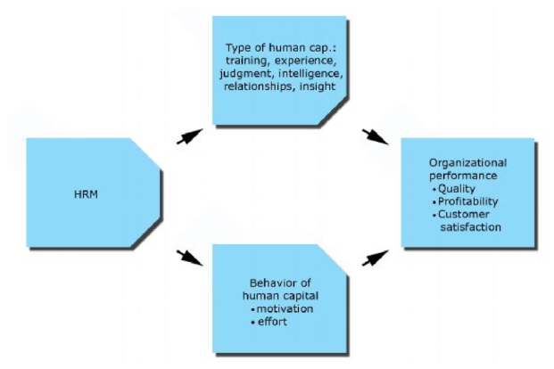

##### Figure 1: Impact of HRM on the organization

(Source: https://www.researchgate.net)

The major roles of HRM can be classified into three types that are discussed below:

***Administrator:*** The administrator department guides the organization in “writing job descriptions”, and “procuring benefit packages” as well as the “creation of policies” in the workplace.

***Change manager:*** This department of HRM entirely investigates the compliance policies of the workplace in support of employees.

***Personal manager:*** This HRM department supervises the “fostering of employee engagement”, and “providing essential training”, and is involved in “resolving conflicts” among employees in the workplace.

As per the research of Alshammari (2020), the key functional area of the HRM in any organization is to hire efficient employees as well as provide training to them for fitting into the workplace of the organization. Monitoring the legislation changes in the workplace and making employees aware of it so any conflicts cannot take place in the organization. They also supervise the safety measures of employees which assist in the maintenance of productivity in the workplace by enhancing the loyalty of employees with the organization.

## 1.2 Research Questions

* What is the importance of the HRM team in any organization?
* What is the impact of the HRM team in the organization?
* How much is the acceptance rate for the HRM team in the organization?
* What are the limitations of HRM in the organization?
* How to improve the challenges regarding HRM in the organization by implementing effective strategies?

## 1.3 Research Aims and Objectives

***Aim***

The aim of this do research is to investigate the impact and effectiveness of HRM on the development of an organization.

***Research Objectives***

* To understand the importance of the HRM team in any organization.
* To assess the impact of the HRM team in the organization.
* To investigate the acceptance rate for the HRM team in the organization.
* To identify the limitations of HRM in the organization.
* To find effective strategies regarding the practices of the HRM for the recovery of the organization.

## 1.4 Research Rationale

The division of an organisation called human resources management (HRM) was created to discover and hire suitable people, empower them, and then help them improve their work ethics so they can realize their full potential and support the objectives of the organisation. By growing the company in the market, they are guided by their engaged involvement in the organization to provide efficient expansion. They help to compile the “mission”, “vision”, “policies”, and “objectives” of the organization together which will be able to guide the organization in the right way for the expansion of the growth in the market.

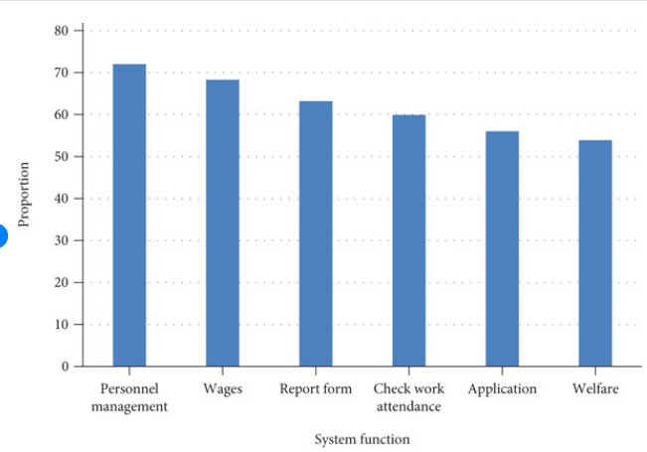

##### Figure 2: Growth of HRM in different fields

(Source: https://www.researchgate.net)

In the organization's place of work, they consistently exhibit high levels of competence. Individuals in the “USA” in the 1960s and 1970s contribute to the progress of the notion of human resources (Bakator *et al.* 2019). The concept of HR as a intangible scaffold for “managing workers”, “tools”, and the “managerial profession” successfully and resourcefully gained distinction in “Europe” and “Australia” in the late 1970s (Stankevičiūtė and Savanevičienė, 2019). From, that time it got the higher response in the organization.

The department of HRM in the organization does not have any limitation on the role they are performing in the various fields of the organization for supervising employees in the organization. By analyzing their performance in the factory they will provide them incentive or reward which is able to maintain work efficiency in the workplace. With these assets, the HRM also has the goal to “reduce risk” and “maximize the returns on investment” for the organization as well as implement effective employees in the proper field of the organization to prevent error-prone work in the workplace (Dixit and Sinha, 2020).

## 1.5 Research methodology

The upkeep of an organization is greatly influenced by human resource management. Its strategic approach offers recommendations for "nurturing" and is deemed to "back organizational needs of personnel. According to the needs of each business, their roles differ**.** For the development of this research secondary qualitative method has been chosen. In this case, to get a favourable outcome for the research a huge amount of data has been collected from the resources like journals, research articles, and white papers. The descriptive research design helps to provide detailed knowledge about the research and the positivism research approach provides in-depth fundamental knowledge of this study without disrupting the originality of the study (NGUYEN *et al.* 2020). These methodological tools guide the thematic analysis of the research so that it will be fruitful for the provision of authentic results for the research.

## 1.6. Research Synopsis

HRM is a branch of an organization that is developed to find and hire qualified candidates, equip them, and then assist them in enhancing their work ethic so they can realize their full capabilities and contribute to the organization's goals. Their active participation in the organization guides them to provide effective growth by expanding the business in the market. They are highly competent and consistent in the workplace of the organization. In this chapter, the research aim and objectives have been established. The chosen methodological tools are effective for the further development of this research in a positive manner.

# Chapter 2: Literature Review

## Section 1:

### 1.1 Introduction

Human resource management, or HRM, altogether affects the presentation of an association. It encompasses a range of practices and strategies aimed at directing HR in an organization to achieve key goals and improve overall execution. Observing the impact of HRM on final success is becoming increasingly logically significant in the serious business environment of today. This literature review aims to examine and synthesize previous research on the link between organizational performance and human resource management. We hope to gain a deeper understanding of the various HRM components that influence an organization's display by examining the available data in this area. Academics and specialists have paid a lot of attention to research on the impact of HRM on hierarchical execution. Exercises relating to HR should line up with key targets for organizations to keep a drawn-out upper hand. Better HRM works out, which center on legitimate execution, is certainly associated with delegating responsibility, effectiveness, and support.

### 1.2 Empirical study

**HRM impact on the performance of the organization**

**According to Anwar and Abdullah (2021),** through technological advancement and connectivity, the economies of numerous nations collaborate to encourage international trade, resulting in an explosion of globalization in recent years. Workforce readiness, vital enlistment, representative preparation, executive development pays, productivity, work relations, medical care, representative fulfillment, and providing various forms of assistance to representatives are all components of HRM. It brings together methods and practices that emphasize delegating responsibility, progressive execution, and the nature of work. The organization employs a uniform HRM framework across the board (Han and Hong 2019). When employees are not performing to their full potential, an organization’s commitment to representative efficiency typically decreases, which helps the company hire more specialists. Agents ought to have more information, capacities, abilities, and experience (Stankevičiūtė and Savanevičienė 2019). An association’s ability to participate in different advantages is affected by human resources the board and HR, the two of which are fundamental for its overall accomplishment.

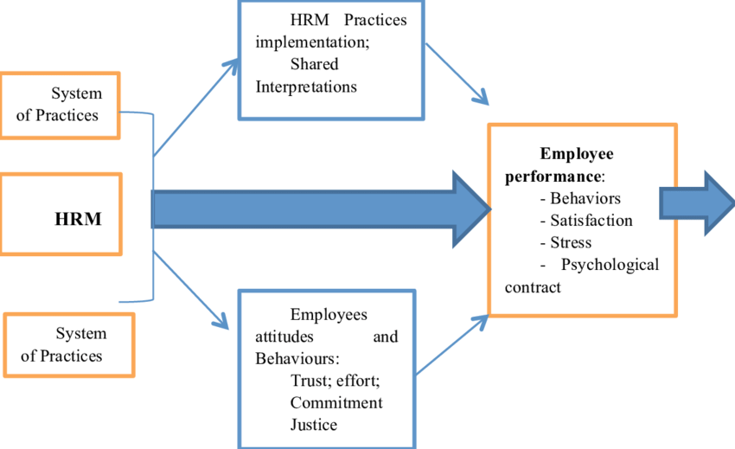

##### Figure 3: HRM Impact on Organization

(Source: https://www.researchgate.net)

Even though the nations surrounding the biggest obstacle to long-term financial growth and profitability are currently unable to comprehend the skills of their skilled workforce, businesses that focus on the developed in some of these countries are currently only looking for the best HR practices that work (Salas‐Vallina*et al.* 2021). The human resource research method, which focuses on human resources, can be used to show that there are resources for many different problems and circumstances. Associations use non-practical resources to obtain a somewhat long high ground. Delegates will not just advantage from a review wanted to broaden a connection’s labor force’s capacity, yet it will besides guarantee that all associates have workers.

The author suggests that training practice and overall outcomes are linked. The relationship between accepting administrative awards and taking risks has been the focus of scientists' research. Additionally, it is recommended due to its positive impact on outcomes. Previous writers’ specialists have put in a lot of effort to keep the impact of compensations on the pages of their writing audits. According to some experts, “a big effect on the execution of a movement”, or “execution improvement”, also supports execution (Danilwan*et al.* 2020). They argued that worker preparation has a clear impact on hierarchical execution. It is battled that before workers can trust in work security, the association ought to first enlighten them that their positions are “safeguarded”. Because it increases representative motivation to perform at a higher level, the association benefits. Observational evidence, as presented by associations, demonstrates that authoritative execution is significantly influenced by professional stability.

**Human Resource management practice and Its Impact**

**According to Alshammari (2020),** Human resources are regarded as the connection's primary resource. To achieve the best possible outcome, affiliations keep HR in mind in a structured manner. As a result, organizations are looking for a data-driven leadership environment that can enroll a group that is right for them. HR experts likewise come from a large number of nationalities, social orders, and foundations, which adds variety to the labor force and makes definitive learning simpler. Organizational culture has a significant impact on beliefs, values, and work practices that either encourage or discourage knowledge sharing and creation. In a similar vein, various levels of culture might alter the final progress and execution (Sabiu*et al.* 2019). The executives’ human capital is the management system for these HR issues.

Gathering a reasonable pool of competitors, enlisting people, choosing, preparing, and making them valuable for the accomplishment of hierarchical objectives are human asset rehearses. Executive human capital is viewed by businesses as a demographic, creative, and financial drain on expansion and improvement. It may appear to be obscure because the term “progressive culture” does not have a single definition (Li *et al.* 2019). This term can be defined in a variety of ways in research. The activities and reactions of a relationship in different circumstances are the most extensively seen significance of genuine culture. Multicultural organizations, therefore, employ this term differently. The definition will be inspected all the more completely the more assorted an affiliation's labor force is. The ability of the board to viewing aggregate or hierarchical information as information is how the information that is used to lay out an organization’s functional cycles is viewed.

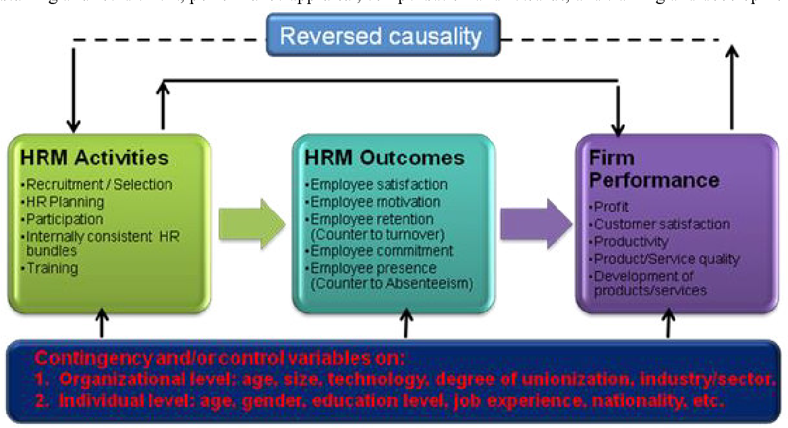

##### Figure 4: HRM activities

(Source: https://d3i71xaburhd42.cloudfront.net)

Additionally, the writing conceals various information translations and exploration strategies that demonstrate the executive's capabilities. The data have been described to establish conviction. The association's presentation about its exhibition has been evaluated in a variety of ways by various examinations. A further evaluation of 17 specific models of genuine capability and execution was coordinated, and several viewpoints associated with the evaluation of different evened-out execution were joined (Suharti and Sugiarto 2020). It is generally accepted that a worker’s performance in an organization is a reflection of their capacity to make a variety of judgments and achieve results based on well-known perspectives like authoritative execution, financial execution, and business execution. Two variables are used to evaluate the market execution of an organization’s benefit-to-piggyback ratio in a second HR framework. In addition, a comprehensive investigation has revealed that the most effective approach for estimating an organization's exhibition is to employ monetary proportions.

**“The Impact of Human Resource Management Practices Competitive Advantage”**

**According to Kerdpitak and Jermsittiparsert (2020),** Employee engagement (EE) has been one of the HR field’s most researched topics in recent years. The planning of this study was based on the hypothesis that an organization’s HR practices, like strategies, need to be tailored to get the most out of commitment. An organization's performance is frequently regarded as a crucial indicator of alignment between HR theories or frameworks and practices. In addition, they demonstrate in their meta-analysis that the AMO structure has both direct and indirect effects on an association’s benefit. On delegate motivation, execution results, HR, and resolute pay (Davidescu*et al.* 2020). The accompanying segment gives a more top-to-bottom portrayal of the degree to which representative commitment straightforwardly impacts individual and hierarchical stories as well as a far-reaching outline of worker commitment given by this review. Agent responsibility is the HR eccentricity that has gotten the most assessment, and trained professionals and scholastics have reliably varied on the most ideal way to portray the term.

Academic researchers, on the other hand, provide a broad definition of employee engagement. Described as a mental expression that is positive, fulfilling, and associated with work, as assessed by importance, energy, and commitment. Recent studies of HRM practices have shown that highly qualified job seekers are always looking for positions that offer a higher level of responsibility and a few unquestionable challenges (Hamouche 2021). Consequently, affiliations ought to engage their HRM system to give a versatile and connecting work area to attract these significantly qualified contenders. Although commitment is at the heart of key HR, it is viewed as the authoritative mix process’s most important benefit that most businesses have overlooked and the reason for winning.

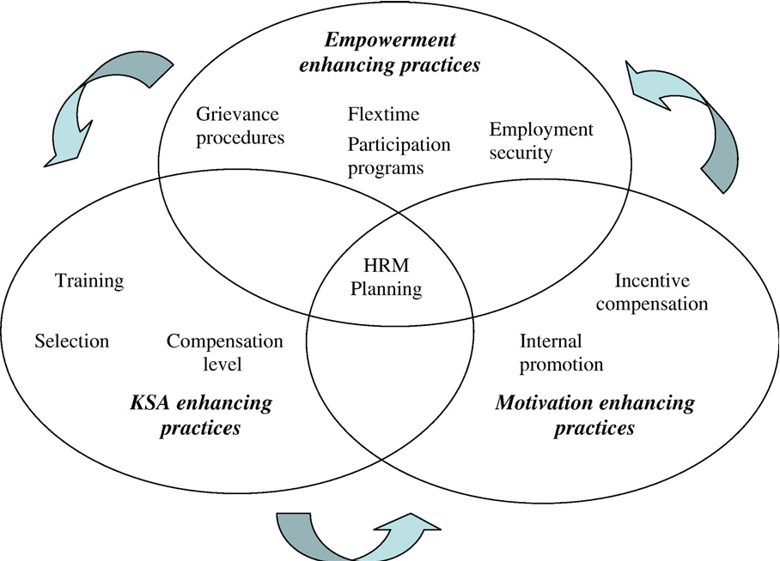

##### Figure 5: Value of Human Resource Management

(Source: https://d3i71xaburhd42.cloudfront.net)

In any case, the tendency to participate in the workplace, also known as the affinity to participate, which ultimately determines the decision-making cycle of associations, is assumed to be the primary explanation for character traits. Tragically, experts have conducted almost no research to comprehend the relationship between decision interaction and authoritative investment. Because conscientious people have a high sense of responsibility and are consequently more likely to be more involved in their work, the conceptual relationship between the five major personality traits and commitment is positively associated with participation (Darvishmotevali and Altinay 2022). Research shows that HRM professionals should try to help employees reach their goals, which will ultimately lead to better performance. "Performance management" is an ongoing procedure that entails a series of actions, such as recognizing, evaluating, and rewarding individuals' and groups' performance to accomplish organizational objectives.

**“The Relationship Between Human Resource Management and Organizational Performance”**

**According to Halid*et al.* (2020),** The rapid development of mechanical technology has a rapid impact on the digitalization of society and continues to have an overall impact on how organizations function. Every level of an organization is affected by the digital revolution. Businesses and employees alike are put under pressure to adapt to the world's rapid change and the rise of digital technology. In the business world, digitization is now regarded as a buzzword that businesses must embrace to remain relevant. PC development has supplanted all physical work in present-day times. Non-repetitive intellectual tasks that can access larger amounts of information, also known as “Big Data”, have also been replaced by intelligent computer programs like artificial intelligence (AI) (Al Doghan*et al.* 2019). As an ever-increasing number of mechanized instruments are connected to the Internet or the “Internet of Things”, detectability is likewise developing. Anything that can be digitized is subject to digitization.

It is altering organizational operations as well as human interaction and communication. There must be a complete shift from manual to computerized strategy and procedure, as well as how executives use their human resources. It is said that cutting-edge HRM essentially utilizes innovation, applications, and the web to deal with all HRM work. Advancements, such as how to recruit, reward, and evaluate employees, should also be covered in HRM exercises. Nowadays, it is common practice to use social media or virtual media to keep valuable employees (Dastmalchian*et al.* 2020). Digital HRM also affects employee training. There are three broad categories of HR transformation: through, in, and out. For instance, a workplace with digital capabilities is required if the company is introverted; All information is transmitted via video, sound, or cell phones, and managers and employees communicate electronically. Worker execution the board is likewise overseen utilizing computerized strategies.

Management or employees gain digital empowerment as a result. Using cell phones will empower workers to do their obligations with more prominent productivity. Workers will be more educated, drawn in, and prepared as a result of receiving continuous criticism because they will be able to oversee and complete their work from any location at any time (Yong *et al.* 2020). Using imaginative work errands and board capacities, work content is becoming electronic. To transform routine manual work into advanced work, associations must incorporate computerized components into their work processes. Affiliations should comparatively utilize advanced devices and media to associate and chat with workers. A high-level relationship between work and tasks inside the affiliation is moreover required (He *et al.* 2019). Planning, putting into action, and utilizing digital technologies are used to support HR management tasks like payroll processing, reward and compensation, performance management, training and development, and other related areas.

**“Human Resource Practices on The Organizational Performance: Does Ethical Climate Matter?”**

**According to Danilwan and Dirhamsyah (2022),** The significance of organizational performance (OP) to an organization’s efficient management has grown over time. Even though most institutions now compete in the product market, market deregulation, globalization, and shifting investor and customer requirements have outpaced the rapidly shifting economic environment. An association’s interior environment ought to be inspected to recognize its challenges and significant open doors to accomplish financial development and keep up with its reality. In addition, these procedures complement one another and depend on one another to guarantee complete and individual (PO) execution (Rubel*et al.* 2021). To put it another way, the act of human asset the executives alludes to the particular authoritative exercises that are expected to utilize the association’s HR and guarantee that the assets are used to their maximum capacity to accomplish the association’s objectives.

As a result, human resource management, or HRM, is focused on a representative’s knowledge and skills in dealing with final execution, as well as financial shifts and advancement. Information about the organization's overall performance that has been gathered from key informants or managers includes subjective organizational performance measures like innovation efforts, efficiency, and effectiveness. On the other hand, a commonly Overpowered assessment method is emotional execution estimation, especially in the administration field (Putra and Ali 2022). Rather than assessing Overwhelmed, the researchers accept that close-to-home measures are a more sensible and reliable choice. For economies that continually need to deal with the pace of financial development, work efficiency and the presence of relationships in the gathering region are fundamental. The majority of modern society is made up of assembling; As a result, there will be more opportunities for the economy to create and produce if all relationships in the gathering region continue to develop rapidly.

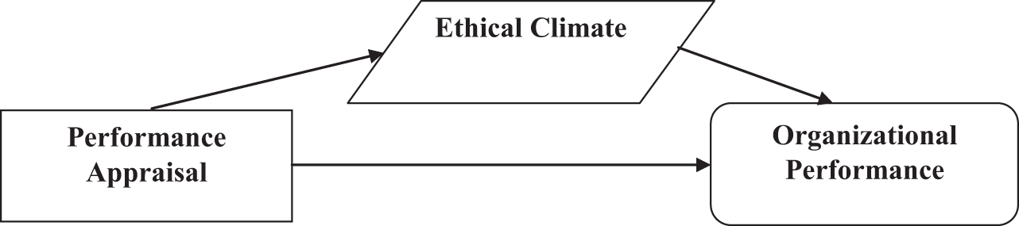

##### Figure 6: Relation between HRM and Ethical climate

(Source: https://www.emerald.com)

A "human resource management" (HRM) system entails persuading HR management to achieve progressive objectives. As a result, it suggests that moral concerns should be taken into consideration when regulating direct labor, such as concerning the affiliation’s characteristics, rules, standards, systems, and plans. Additionally, the effects of the organization’s functions have a significant impact on the capacity of the human resource management system to influence employees' ethical behavior (Abbas and Kumari 2021). Human asset chiefs guarantee worker inspiration and, therefore, association inspiration. They plan their arrangements to keep representatives connected on the path to advancement, promote clear methods, and clarify the career paths of their employees. Representatives are more productive when HRM development exercises are carried out, and as a result, the organization can achieve its objectives of exceptional execution ***[Referred to appendix 1]***.

**“The Effect of HRM Practices and Employees’ job satisfaction on employee performance”**

**According to Mira *et al.* (2019),** as the worldwide market turns out to be progressively difficult and dubious, various organizations have zeroed in on HR exercises to conquer deterrents and gain an upper hand. Human resource management (HRM) can manage a connection’s abilities, information, imagination, supportive energy, commitment, and results. In this manner, HRM expects a crucial part in helping relationships with achieving their objectives in various fields. As businesses increasingly face advancements and changes, HRM can combat a variety of shifts by implementing a variety of strategies to increase employee satisfaction (Zaki and Norazman 2019). The association's proficiency is affected by these strategies. Human asset capabilities include preparation and development, reward, work investigation, enrollment and determination, representative relations, worker strengthening, and social assistance. Each of these approaches needs to be developed to achieve higher levels of employee contentment and productivity.

The organization should consider human asset rehearses as the essential method for accomplishing its goals through worker execution. Training and development, compensation, job analysis, recruitment and selection, social support, employee relationships, and employee empowerment are the seven aspects of human resource practice that positively affect employee performance. Subsequently, the association attempts to choose the best individuals who have what it takes and the ability to impact these factors positively (Njoku*et al.* 2019). Supervisors in every organization have a responsibility to appropriately influence individuals involved in executive exercises because the progress of human asset exercises is dependent on how they are carried out. In addition, a lot of researchers have said that HR activities increase employee satisfaction at various organizational levels, which in turn improves employee performance.

The connection between job satisfaction and representative performance is an essential component of authoritative brain science. Consequently, in a variety of endeavors, numerous experts have attempted to investigate the connection between representative performance and job satisfaction. Work fulfillment has a significant impact on representative behavior because it increases commitment, execution, faithfulness, and responsibility. there will be a reduction in the speed of reductions, setbacks, fights, deferrals, and non-appearance (Kuria and Mose 2019). Work fulfillment further develops representative execution through its role as a mediator. Chiefs need to carefully consider how to perform so that workers are more satisfied and give their best effort. By looking at work satisfaction as a central individual, various observational assessments demonstrate a positive association between HR practices and execution through work satisfaction in various fields.

**“Human resource management (HRM) practices and organizational performance”**

**According to Otoo (2019),** Hierarchical partners expect all business capabilities, including HR, to demonstrate their dedication to the organization's exhibition in the current hyper-serious environment. The overall performance of the business as a whole, and making sure that the HR department helps the company reach its goals. An HRM practice is a collection of practices that an organization uses to manage its human resources to maintain a competitive advantage by facilitating the development of skills specific to the company, fostering intricate social relationships, and expanding knowledge of the company. The concept of authoritative execution has many layers and is complicated (Al-Qudah*et al.* 2020). A company’s success depends on its ability to successfully implement methodologies for achieving hierarchical goals. In terms of the extent to which the organization achieves its goals, it is referred to as authoritative execution. In their quest to investigate and establish synergy between HRM and organizational performance, several practitioners and academics have advanced theories and concepts.

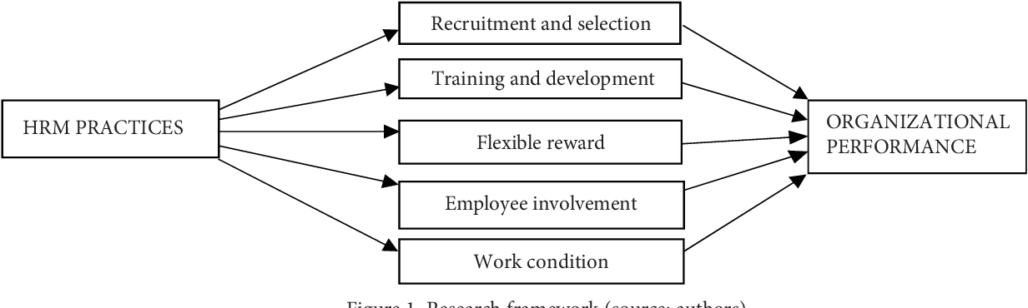

##### Figure 7: HRM practices

(Source: https://d3i71xaburhd42.cloudfront.net)

The review identified center abilities, academic capital, hierarchical capabilities, superior execution work frameworks, and elite execution groups as important methods for analyzing the connection between HRM, execution, and authoritative adequacy (Hee*et al.* 2019). Similar to this, a variety of authors have conceptualized and experimented to establish a positive connection between particular HRM exercises and hierarchical execution. The subject of how to delegate capacities interface with HRM practice and definitive execution can be better-gotten handled on account of this study’s basic exploratory revelations. Employee capability is influenced by recruitment and decision mediations, preparation and advancement mediations, and representative commitment mediations, according to the study’s findings (Arifani and Susanti 2020). Through enlistment and determination, organizations increment their upper hand furthest degree conceivable. The motivation behind planning and advancement mediations is to keep up with and improve an association’s suitability and capability.

## Section 2:

### 2.1 Theories of Model

***Theories:***

**Resource-Based View Theory**

Human resource management (HRM) has a significant impact on an organization's performance, and resource-based theory (RBV) provides a useful perspective on this topic. RBV sees that an affiliation's assets, including its HR, are the fundamental determinants of its strategic position and execution. According to RBV, HRM practices assist in the production and utilization of an organization's human resources, which are significant and insufficient resources that can provide the organization with a prolonged advantage over competitors (Havidz and Gupron 2019). The board's human resources act covers a wide range of activities, including executive hiring and selection, improvement and planning, executive execution, and employee relations payment and management.

If these exercises are very much arranged and done, it could be trying for opponents to secure a significant and unique human asset. As a result, they can recruit, develop, and retain talented employees. "Fit" between HRM practices and the affiliation's fundamental goals is one aspect of RBV. Employees can assist the organization in achieving its strategic objectives when HRM practices align with those objectives (Hee*et al.* 2019). An organization that wants to make a difference in the world through innovation can benefit from HRM strategies that emphasize creativity, continuous learning, and cross-functional collaboration. a labor force that can consider new ideas, which work on functional outcomes.

In addition, RBV emphasizes the significance of HR management practices that are unique to a company or idiosyncratic. Rather than just utilizing standard HR chief systems, these strategies are customized to the specific necessities and attributes of the association. By developing HRM practices that are in line with the organization's way of life, values, and central setting, organizations can cultivate an advantage that is difficult for competitors to duplicate (Arifani and Susanti 2020). According to RBV theory, human resource management practices are crucial not only for attracting and keeping talented workers but also for developing their skills, knowledge, and limits. The board exercises productive human resources, which can further develop representative skills and thus improve individual and group execution. The RBV also demonstrates that HRM exercises can influence representative mentalities and behavior patterns, such as employee execution, work satisfaction, and hierarchical responsibility.

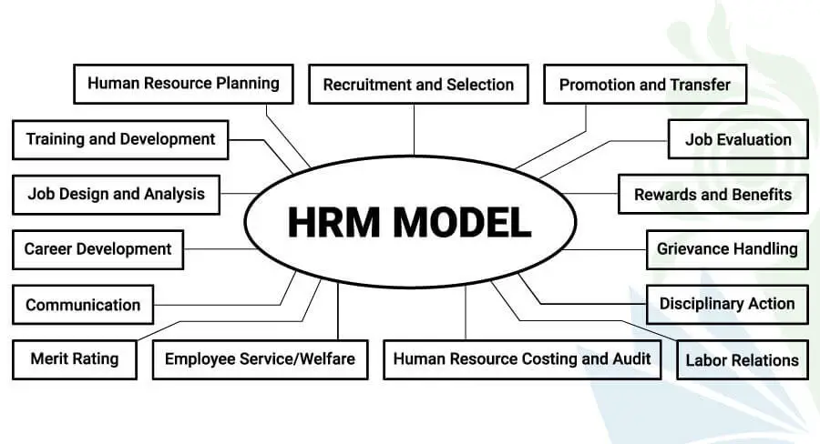

##### Figure 8: HRM models

(Source: https://higherstudy.org)

**High-Performance Work Systems (HPWS)**

Human resource management (HRM) influences an affiliation's show, and (HPWS) speculation gives a huge point of view. According to the HPWS theory, a comprehensive set of practices for human resource management can improve employee skills, motivation, and engagement, which in turn can improve employee performance. association moves forward (Havidz and Gupron 2019). The HPWS hypothesis states that instead of being carried out independently, human resource management activities ought to be carried out in a coordinated and consistent manner. As a result of this blend, HR practices are guaranteed to collaborate to lay out a helpful work environment. Specific enlistment, extensive planning and improvement programs, execution-based rewards, worker commitment along the way, and information sharing are all important components of HPWS ***[Referred to appendix 2]***.

Explicit enlistment refers to the most common method of recruiting and selecting individuals who share the fundamental capabilities, skills, and values of the organization. Organizations can broaden their talent pool and increase the likelihood of high performance by attracting and selecting candidates of high quality. In HPWS, comprehensive training and development programs are required (Opatha 2019). These endeavors plan to upgrade workers' abilities, information, and cutoff points, assist them with playing out their positions, as a matter of fact, and add to the progression of the connection. Open entryways for preparation and progress also indicate an organization’s commitment to delegate development, which can also foster professional motivation and responsibility.

HPWS heavily relies on rewards based on performance and the organizations can motivate employees to strive for greater success by connecting rewards such as prizes, advancements, and affirmation to individual and group performance. By providing an unmistakable link between effort and desired outcomes, execution-based rewards foster a culture of superior execution. At HPWS, employees are encouraged to participate in decision-making and information sharing. A sense of belonging, strength, and responsibility among delegates is promoted by affiliations that attract workers on the road and provide direct communication channels (Qablan and Farmanesh 2019). According to HPWS theory, a positive working environment that encourages professional satisfaction, responsibility, and motivation is created when these HR practices are effectively connected and carried out. improving the organization's performance as a result. A powerful and consistent structure for tip-top execution is made by the mix of these practices and their common help.

**Institutional Theory**

The understanding of how an organization’s exhibition is affected by human resource management (HRM) can benefit from the institutional hypothesis. This hypothesis focuses on the impact of external institutional tensions on HRM exercises and their subsequent impact on hierarchical execution. As per the institutional theory, associations' activities and systems are affected by the social and institutional settings in which they work. Tension within institutions is exacerbated by a variety of factors, including accepted practices, values, guidelines, industry standards, and others (Muisyo*et al.* 2022). To gain legitimacy and acceptance, organizations frequently implement HRM practices that are regarded as "legitimate" and conform to prevailing organizational expectations. Some HRM practices are adopted by organizations, according to institutional theory, not only because they are effective but also because external stakeholders accept them.

The HRM field can benefit from this and live up to cultural expectations and establish authenticity among partners, socially and legally, Variety and incorporation drives or ecological manageability programs, for instance, can be carried out by associations. The social event of overseeing human assets and the manager’s practices can affect an association's show in different ways. In any case, sticking to strict expectations can damage an organization's reputation and image, which can have a significant impact on customer perceptions, attract competent representatives, and energize organizations. Positive relationship with partners These factors may improve authoritative performance. employee behavior and attitudes can be positively impacted by HRM practices that are institutionalized.

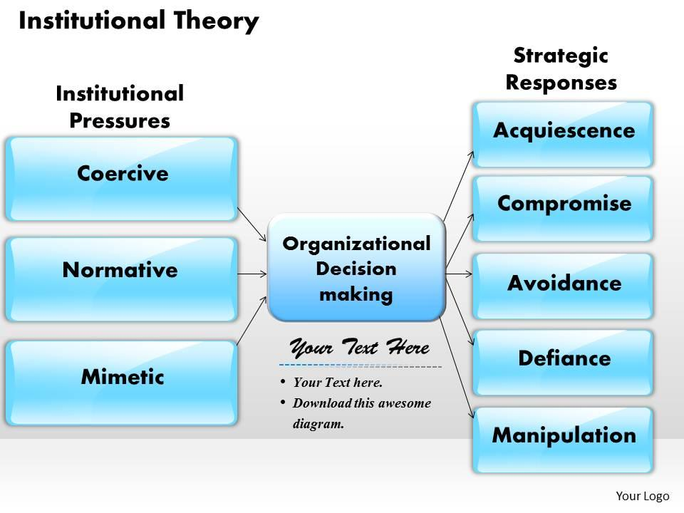

##### Figure 9: Institutional Theory

(Source: https://www.slideteam.net)

Delegates can foster a more solid sense of trust, obligation, and devotion precisely when they discover that their organization adheres to commonly used human resource practices. As a consequence of this, it might lead to increased levels of representative commitment, job satisfaction, and execution, all of which will ultimately have an impact on authoritative execution (Julius *et al.* 2022). However, it is essential to keep in mind that institutional tensions do not always relate to the organization's primary goals or specific requirements. In these circumstances, it may be challenging to adjust to hierarchical assumptions and adopt the human assets the board practices that are most appropriate to the particular setting of the association. Finding a concordance between institutional tensions and internal key assessments becomes fundamental for the relationship to accomplish ideal execution.

**Social Exchange Theory (SET)**

An important point of view for comprehending how human resource management (HRM) influences an organization’s performance is provided by the (SET). This theory says that employees’ attitudes, actions, and performance are influenced by communication with the company. According to the social trade hypothesis, employees enter into a social trade relationship with their manager in which they contribute effort, expertise, and time in exchange for benefits and compensation (Kowang*et al.* 2019). This exchange has the potential to be shaped by HRM practices, which in turn can affect employees’ perceptions of fairness, trust, and reciprocity, which in turn affects motivation and commitment. Employees will develop a sense of duty and commitment when businesses invest in HRM activities to create positive social exchanges, such as fair treatment, supportive leadership, career development opportunities, and recognition.

When they know that their contributions to the company are valued and rewarded, they are motivated to work harder and perform better. In social exchange relationships, fair and equitable treatment in human resource management practices is essential. Workers assess whether they are overseen truly to the degree that pay, types of progress, execution surveys, and dynamic cycles. Laborers are probably going to answer with more noteworthy amounts of exertion, obligation, and execution when they see fairness in these HR works out (Fei*et al.* 2019). Management is another important aspect of social trade. Directors and managers cultivate positive relationships with representatives by showing courtesy, assistance, and appreciation to their subordinates. Through the development of representative trust, happiness, and faithfulness through steady initiative practices, expanding functional results is conceivable.

Reviews in human resource management that support professional success and advancement additionally further develop social trade connections. Employees will discover that their long-term career goals are taken seriously when businesses invest in employee development through training, mentoring, and advancement opportunities. This encourages more creativity and action while also fostering a sense of connection. HR practices that encourage positive employee relationships, such as teamwork, collaboration, and organizational culture, also have an impact on social exchange relationships. Employees are more likely to respond with increased effort and performance in a positive work environment marked by cooperation, mutual support, and a sense of belonging.

***Models:***

**AMO model**

The AMO model looks at three main factors to figure out how HRM exercises affect performance: opportunities, motivations, and capabilities Employees' competence is defined by their knowledge, abilities, and skills. Employee performance is improved by HRM activities like training, skill development, and job design. By giving assets and opening doors to workers to acquire new abilities, an association can perform better. Inspiration is an important part of a representative exhibition, and HRM exercises that encourage inspiration, such as vocation improvement opportunities, execution-based rewards, and strong initiative, can improve employee commitment and responsibility. Agents are urged to attempt, give their all, and endeavor tip-top execution through these practices in the working environment (Shrouf*et al.* 2020). Opportunity is the specific situation and emotionally supportive networks of an association that assist representatives with utilizing their abilities and inspirations to their maximum capacity. Approaches to human resource management that provide employees with challenging tasks, autonomy, and supportive work environments are among the factors that contribute to improved performance.

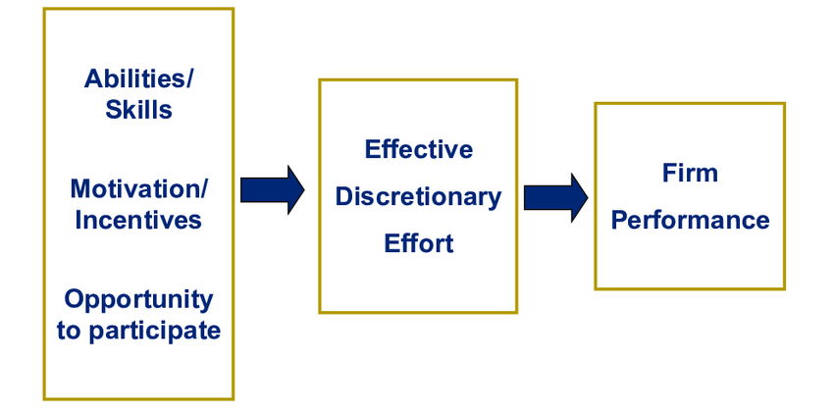

##### Figure 10: AMOL Model

(Source: https://www.researchgate.net)

When workers approach resources, support, and valuable opportunities to put their skills and inspirations to use, they are bound to perform at a higher level. The ability, motivation, and opportunity interdependence is recognized by the AMO model as a performance-inducing factor. It zeroed in on that an extensive technique for overseeing HRM, considering three elements, is fundamental to accomplishing ideal utilitarian outcomes. Organizations should invest in human resources the board exercises to improve representatives’ capabilities, motivate them, and provide opportunities for them to use their talents and skills (Yusoff*et al.* 2020). Utilizing the AMO model, organizations can more deeply study what the human asset the board rehearses mean for individual and hierarchical execution. By zeroing in on individual factors that impact execution, this model stresses the meaning of fitting HRM practices to upgrade worker capabilities, inspiration, and open doors. In the end, bringing HRM practices into line with the AMO framework may result in increased productivity and success for the business ***[referred to Appendix 3]***.

**The Harvard Model of HRM**

The integration of HRM practices with organizational strategy, employee influences, and situational factors is emphasized in this model. At the focal point of the Harvard model is the probability that human asset the block exercises should be fixed with the central objectives of the connection. Human resource management is an essential component of an organization's overall strategy, so it is not considered a separate function. The model recommends that HRM strategies ought to be created such that upholds the organization’s central goal, values, and objectives. Agent influence is furthermore complemented in the Harvard model of human resource the board. He suggests that representatives should have a voice and participate in the dynamic that has an impact on them (Somu*et al.* 2020). By giving employees a sense of belonging and strengthening, associations can increase representative commitment, inspiration, and fulfillment, ultimately leading to improved functional execution. The model moreover perceives the significance of situational factors in concluding whether HRM works out. Legal and regulatory requirements, industry standards, cultural and social influences, as well as other external environmental factors, have an impact on human resource management.

HRM activities ought to be fragile to these external variables and flexible to the affiliation's specific setting, according to the Harvard model. The Harvard model likewise distinguishes three extra components that affect an association's exhibition, laborer suitability, agent capacity, and specialist responsibility. Agent capacity alludes to workers’ information, capacities, and abilities. Through efficient recruitment, training, and management, HRM practices ought to have the objective of attracting, developing, and retaining competent employees. Up close and personal association, dedication, and conspicuous confirmation among agents are portions of specialist responsibility (López‐Cabrales*et al.* 2021). Representative commitment can be increased through HRM practices that recognize and reward employee commitments, create opportunities for career advancement, and foster a positive work environment. The arrangement of individual and organizational goals and values is referred to as “worker fit”. HRM practices should aim to develop a shared understanding of the organization’s goals, values, and standards to ensure that employees' individual goals are compatible with the organization's mission.

### 2.2 Literature gap

HRM's overall impact on performance has been studied, even though the HRM activities that have the greatest impact on organizational performance require additional research. The majority of studies outline HRM practices without clearly identifying which HRM practice has a greater impact on performance. It is anticipated that additional research will reveal explicit procedures that are most effective in a variety of authoritative settings (Dirhamsyah*et al.* 2020). Contextual factors like industry type, organization size, and location also have an impact on organizational performance. Be that as it may, the writing as often as possible neglects to completely represent these relevant variables while inspecting the association between HRM and execution. Future examinations ought to consider these relevant elements to figure out what they mean for execution and interface with HRM exercises. Likewise, despite the way that surveys have shown a positive relationship between HRM and various leveled execution, the essential instruments by which this affiliation works are still insufficiently seen.

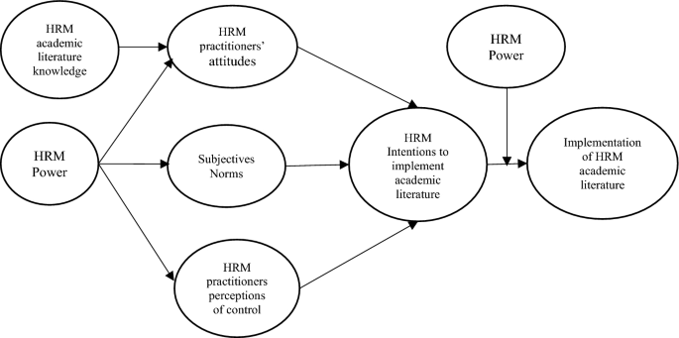

##### Figure 11: Literature gap in HRM

(Source: https://media.springernature.com)

It is guessed that extra exploration will examine the supporting frameworks that make sense of how HRM practices impact execution results. Worker responsibility, inspiration, and perspectives may, for example, act as the go-between in investigations of this relationship. Hierarchical culture has an impact on the executives' human assets as well, which has a direct impact on execution. However, organizational culture is frequently overlooked in the literature when it comes to comprehending the link between HRM and performance (Isnaini*et al.* 2020). Future research ought to focus on the impact of authoritative culture on execution and the role it plays in the reception, execution, and viability of HRM exercises. In addition, it is more difficult to comprehend how HRM influences organizational performance over time due to the use of a cross-sectional design in many studies in this field. Longitudinal examinations that track HRM practices and execution after some time are fundamental to grasping the powerful idea of the relationship and laying out the circumstances and logical results relationship.

### 2.3 Conceptual framework

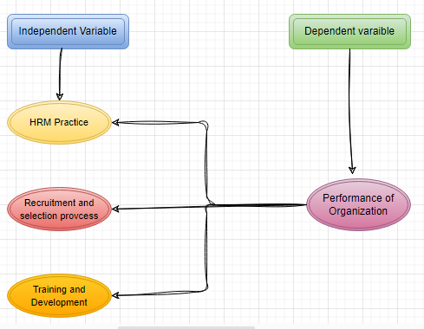

##### Figure 12: Conceptual framework

(Source: Self-Created in Draw.io)

|  |  |
| --- | --- |
| ***Dependent variable***  **Performance of Organization:**  It is any significant achievement metric, such as general proficiency, productivity, or efficiency, that is used to evaluate an organization's presentation. This proposal aims to investigate how various methods of human resource management influence and contribute to hierarchical execution. Performance metrics include things like customer satisfaction, employee satisfaction, and market share, which are non-financial metrics (Joarder*et al.* 2019). Financial metrics include things like revenue growth and return on investment. The review means to furnish associations with an understanding of how to further develop execution by upgrading HRM techniques by inspecting what HRM rehearses mean for authoritative execution. complete limit | ***Independent variable***  This independent variable focuses on the organization's strategies, procedures, and methods for attracting, evaluating, and selecting qualified candidates for employment. It is important to look at a CV, lead a meeting, and check references. The proposal will investigate how effective enrollment and decision practice support hierarchical execution. It may, for example, examine the issue of whether organizations that utilize careful determination cycles and enroll people with the essential abilities and capacities accomplish unrivaled execution. This independent variable focuses on initiatives and activities designed to improve employees' knowledge, abilities, and skills. It includes development-related programs, classes, mentoring, instruction, and other activities. The suggestion will look at major areas of strength for what movement rehearses mean for how well a requested capability. It can explore whether expanding amazing open doors for nonstop learning and putting resources into representative advancement further develop organization execution ***[Referred to appendix 4]***. |

### 2.4 Summary

The establishment for deciding the effect of HRM on progressive execution is given by these speculations. The resource-based point of view stresses HRM activities' fundamental worth, while world-class execution structures underscore the meaning of facilitated HRM works out. Suppositions speculation emphasizes the occupation of motivation, whereas social exchange speculation is based on the association between workers and relationships. The mental agreement hypothesis stresses the meaning of meeting representative assumptions; though the institutional hypothesis considers the impact of outside factors. A writing survey that glances at these speculations is an effective method for getting a total comprehension of the association between HRM and hierarchical execution. RBV can appreciate what HRM means for the presentation of the organization by creating rehearses that are one of a kind to the organization, adjusting HRM practices to vital objectives, and zeroing in on the improvement of representative abilities and uplifting perspectives. However, to ensure that HRM activities satisfy their specific requirements, organizations must also consider their particular strategic goals and operating environment. If businesses want to use HRM practices to boost performance, they must know how to navigate the institutional landscape.

Additionally, the models discussed provide a logical framework for comprehending the impact of HRM on organizational performance. Human resource management practices ought to be integrated with the organization's strategy and employee interests, according to the Harvard model. Taking into account workers' abilities, motivations, and entryways, the AMO model shines lights on instruments at the individual level. By focusing on representative capability, commitment, and reasonableness, associations can create a steady workplace that improves worker execution and contributes to hierarchical achievement. office. The impact of HRM on legitimate execution will be better seen expecting these openings in the composing are filled. By focusing on specific HR management approaches, examining contextual factors, examining mediating mechanisms, incorporating organizational culture, and conducting longitudinal studies, researchers can improve our comprehension of this topic and provide insight to businesses seeking to optimize HR management strategies to boost performance.

# Chapter 3: Methodology

## 3.1 Introduction

The methodology section will justify the research producers, which have been taken to determine the impact of HRM on an organisation. It is relevant to study the current effects and their relationship with the modern organisation. The performance metric is one of the critical criteria to determine the productivity rate an organisation is currently maintaining. The research has chosen various methodological practices to opt for the best result the study can produce. It has been effective with the advent of ***“web-based HRM systems”***, and has encouraged organisations to delve into ***“Enterprise Resource Planning” (ERP)***, which helps in the standardisation of a business process (Al-Harazneh and Sila, 2021). This has led to a series of development in this segment. Therefore, it provides a broad area for the researchers to discover the effects it is having on the employees of an organisation and how successful it is to create a system, where the organisation gets benefitted both internally and externally.

## 3.2 Research Onion

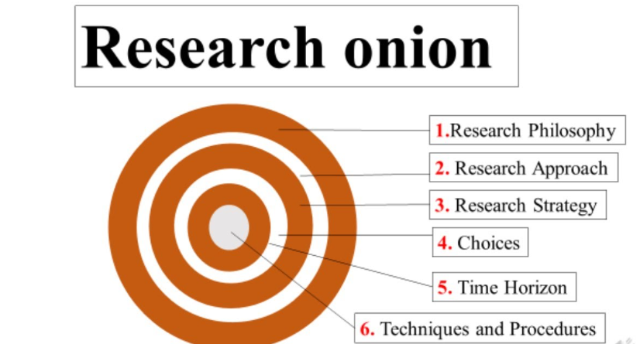

##### Figure 13: Research Onion

(Source: Saunders, 2020)

## 3.3 Research Philosophy

The research philosophy helps to understand the reader to get an idea about the perspective of the research that has been conducted. HRM processes have several roles, which include ***planning company policies*** and ***people management guidelines***. In order to do that it is involving welfare of an employee working in that particular organisation. For addressing that angle the research has chosen the ***interpretivism research philosophy***. It will help to assess the perspective of the employees and other company stakeholders to understand how the companies and its staff are benefitting or suffering from the new practices of “Human Resource Management”.

***Justification:*** This philosophy will help the readers to understand the improvement in HRM from the perspective of an employee and managers in general. A company has its chain of hierarchy and to increase accountability between teams, the company implements HRM practices, which affect the existing workflow. To understand its positive and negative significance, the research will observe multiple realities faced by the company employees and also of the managing directors and other senior managers to understand its business implications and to gauge whether it is benefitting these companies. Hence, this research philosophy is the most preferred one for this study.

## 3.4 Research design

The research design chooses a way to discuss the research’s subject matter. In this scenario, to understand the research’s main theme, the study will use case studies and can use observation to discover the trends related to this topic. For this research, a ***descriptive research design*** has been chosen. This topic needs a detailed approach to discuss the impacts of HRM on the administrative activities of an organisation.

***Justification:*** Eyupoglu. and Tashtoush, (2020), states that HRM practices have a role in shaping ***“organisational citizenship behaviour”***. This shows that there are enough studies, which imply the importance of HRm in an organisation’s environment. This study aims to gather all the relevant information from multiple sources to look at all aspects and present a study, which will factor all the implications of multiple stakeholders. This will create significance for the readers to gauge the importance of this technology. Its role in the ***“compensation system” (CS)*** and ***“performance appraisal” (PA)*** has been a factor to meet the employees’ needs and fulfil the organisational promises (Eyupoglu. and Tashtoush, 2020). From all these factors, it can be judged how essential it is for understanding all the aspects of an organisation. Therefore, a descriptive research design has been chosen to assess all the information accurately.

## 3.5 Research approach

In order to understand the implications of the HRM it is essential to source quality and peer-reviewed information. Since the technology is there for a long time and got recent improvements, hence it is critical to determine how these changes are helping the organisations. For performing such a bros study, the researchers have taken the ***deductive approach*** to finding the relevance of existing HRM theories. The deductive approach is useful to find a relationship or to deduce any cause-relation benefits, which can be informative for the study (BRM, 2021). This finally helps to judge and analyse various hypotheses.

***Justification:*** One such hypothesis is that HRM practices have a direct correlation with the type of organisational culture a company creates (Ramadistaa and Kismono, 2020). This becomes an important criterion to form or break a type of culture by changing HR practices. This study judged various other theories presented by the scholars and held those under scrutiny to essentially find how those are relevant to the current working conditions. It has also analysed the perspective of the employees and the HRM practices, which allows them with work-life balance and scope to improve their careers. Therefore, the deductive approach is the most suited for this study.

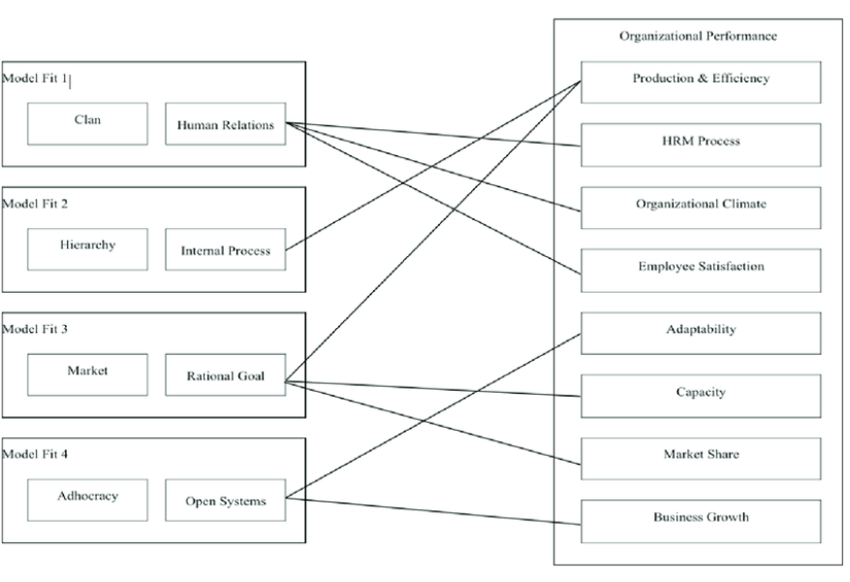

##### Figure 14: A hypothesis of HRM practices and their impact

(Source: Ramadistaa and Kismono, 2020)

## 3.6 Research Strategy

In order to find and gather all the relevant information the study has aimed to gather all the resources from relevant sources. It will store all the relevant information about the study and thus will gather it from ***secondary sources***. This strategy has helped the researchers to access all the theoretical information and helps in the process of analysis. The researchers have opted only for secondary data as there is ample research, which is already prevailing in this field so the deductive approach can be followed only when the study will entirely focus on the existing theories and will try to deduce meaning out of them.

***Justification:*** For example, the research will analyse how it is effective to understand and segregate the high performers in an organisation and the role of HRM practices to develop more high performers (Lockhart *et al.* 2020). In order to efficiently do that, the study has looked at several research papers, analysing the impact it has on the rest of the organisation. For this purpose, the secondary research has helped the researchers to scheme through all the academic materials. This has helped the study to determine the ***success rate of effective HRM practices***. Hence, this research strategy is sufficient for completing the study successfully.

## 3.7 Research method

In the research method, it is essential to understand what kinds of data are important for the study. For determining the impact of HRM on an organisation it is mandatory to collect ***qualitative data*** from multiple sources.

***Justification:*** There are various stakeholders, who are involved in the HRM practices. In the current state, companies are willing to cultivate ***“Organisational citizenship behaviour”*** among their employees (Eyupoglu and Tashtoush, 2020). It aims to make the employees take ownership of their tasks and encourage behaviour and practices, where an employee can do work outside their contracts. This habit of organisations is vital for ensuring the success of the company. The study has delivered a detailed analysis of how that is beneficial for the company to cultivate such habits within its employees. For this study, quantitative data is not that impactful as it can be skewed towards a specific set of biases and fails to give underlying intentions, which are there for such answers. Hence for a deductive research approach, this method is not suitable for concluding the impact of HRM. The researchers have, therefore, chosen this research method to get all the authorised information and statement of various HRM theories, which are effective for producing a qualitative study.

## 3.8 Data collection methods

Data collection is a process of gathering information, which is relevant to a particular cause and is effective to find out the results of particular hypotheses and to determine an outcome of a particular problem (HHS, 2019). This step is the vital step in a research process, as finer the data more accurate will be the results. This is a critical step and requires a more dedicated effort to source and gather all the relevant information. For this study, ***secondary qualitative data*** will be gathered.

***Justification:*** Modern HRM theories, such as, ***“increased datafication”*** in the HRM processes could be beneficial for the growth of the companies (Cheng and Hackett, 2021). This kind of research data is important to analyse how data in the HRM process is creating an impact within an organisation. This shows the ***importance of gathering qualitative data from reputed academic journals and articles***. It can be suggestive for getting primary data also but the relevance and authenticity will lack in that kind of data. The research can get an opinionated outcome, which might not become relevant to the present and existing practices. Thus, the data collection method got restricted to only dealing with academic journals, where the theories about HRM practices are prevalent.

## 3.9 Data Analysis

In this, it is critical to form a conclusive statement about the study. Data analysis is the process, where the researchers will develop a judgement based on a prescribed form of data analysis. It helps to describe and form analytical results, which helps a researcher to interpret context and perceptions (Maguire and Delahunt, 2017). For this study, the researchers have chosen ***thematic analysis***.

***Justification:*** Thematic analysis is an essential process to determine ***“patterns” or “themes”***, from the set of qualitative data (Maguire and Delahunt, 2017). Since this research has gathered a variety of qualitative data, to meet the objective of the study thematic analysis will be perfect to find the solution to respective theories. It has helped the researchers to find patterns between multiple HRM theories and their relevancy in the current context. This is effective for the researchers to come up with a conclusive statement, which is then can be summarised to give an overview of the impacts of HRM across industries. In diagnostic analysis, the researchers aim to find a solution for a particular problem and focused mainly on a particular niche. In order to cover a broad topic, patterns are more beneficial to give the reader an overall scenario about the existing practices and norms. Hence, thematic analysis is the best process to interpret data for this study.

## 3.10 Research limitations

The research has covered all the essential traits, which are essential for finding the broad impact of HRM practices in an organisation. This includes judging all the theories and their implications in terms of execution. Understanding the role of ***big data*** and ***Industry 4.0 technologies***, which are essential for the growth of an organisation in the 21st century. However, the study has not analysed any primary data, which shows that it has to be dependent on secondary data to get inputs from the people regarding this matter. The risk of getting an opinionated viewpoint has ignored the input from the primary research. Following are the things, which got neglected due to lack of primary evidence. The inputs from the company managers and their current responsibility to manage a team. It has not accounted for any HR personnel for the benefits or drawbacks of modern HRM practices. Along with that, the research has also taken inputs of HRM practices from different countries. While doing that the research has ignored the cultural aspects, that an organisation goes through while expanding. Therefore, in some instances an HRM practice can sound unproductive but it has a lot of cultural significance for that particular region. Due to thematic analysis, the researcher has not considered this factor and focused mainly on the perspectives of an organisation and the people within it.

## 3.11 Ethical considerations

The researcher has maintained and followed all the ethical guidelines provided by the university. It has maintained the ***law of plagiarism*** and followed the ***“Information protection act”*** to maintain the confidentiality of the data. It has accessed all the information from first-party sources and avoided extracting information from third-party sources by breaking the piracy law.

## 3.12 Summary

It can be summarized that the research has followed a proper methodology by implementing an ***interpretivism research philosophy***. It has chosen this ideology to analyse the human angle present in the study. It has taken a deductive approach, which will help the researchers to determine the nuances between different practices. The data collection process has justified taking secondary qualitative data and delivering a detailed analysis by following thematic analysis. It has pointed out several research limitations and a lack of evidence gathered from primary sources. Hence, this methodology section gives a detailed understanding of the process of the research.

# Chapter 4: Finding

## 4.1 Introduction

The impact of HRM (human resource management) on an organization's performance is the subject of this chapter. The major local area is to see the value in the meaning of the HRM bundle inside an alliance and assess its effectiveness. Moreover, the acknowledgment pace of the HRM group, the limits of HRM, and viable ways to deal with an association's recuperation through HRM practices will be explored. HRM plays a crucial role in any relationship by overseeing the workforce and implementing plans that align with the organization's objectives. Understanding the HRM team's contribution to the overall performance and success of the organization is essential to comprehend their significance. The HRM group's drives and exercises must be deconstructed in order to evaluate their impact on hierarchical execution. The areas where HRM exercises can be strengthened and have a positive impact are identified in this analysis.

The goal of the HRM team acceptance rate investigation is to learn how the business views and values the HRM function. It investigates how well the HRM team is supported and worked with by the company's other departments and employees. Distinguishing HRM's limits inside the association can be vital for resolving issues that might ruin the HRM group's adequacy. Realizing these constraints enables relationships to develop strategies for overcoming them and advancing HRM practices. HRM exercises are especially crucial for determining efficient strategies for authoritative recovery during times of crisis or problems with hierarchy. HRM can expect an essential part in the creation and execution of techniques that aid in the recovery and strength of the affiliation. In this research analysis for the performances was maned in the HRM impact for the organizations.

## 4.2 Analysis

### 4.2.1 Strategic Alignment and Goal Achievement

The HRM group is fundamental with regard to adjusting HR arrangements and practices to the association's essential objectives and goals. By understanding the general business system, they develop HR techniques that help and add to the accomplishment of these objectives (Anwar and Abdullah 2021). To ensure key arrangements, the HRM group works with other divisions and senior management to identify the organization's HR requirements. They investigate the ongoing labor force recognize regions in which abilities are missing and plan for enlisting and preparing to find and prepare the proper people. Additionally, the HRM group develops execution goals and metrics that are in line with the organization's goals. They use execution-the-board structures to screen and assess representative execution giving recognition and analysis to energize steady improvement.

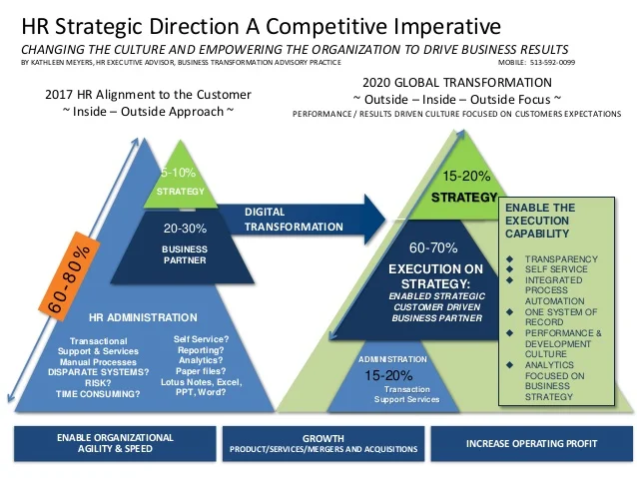

##### Figure 15: HR strategies

(Source: https://image.slidesharecdn.com)

### 4.2.2 Talent Acquisition and Retention

The HRM bunch puts a huge accentuation on gaining and keeping up with top ability. In order to find the best candidates for the company. They come up with and implement efficient recruitment strategies making a set of responsibilities, advertising open positions, conducting internal and external evaluations, and holding meetings to select the best applicants are all part of this (Alshammari 2020.). The HRM team focuses on delegate support strategies when the ideal candidates are selected. They provide competitive compensation and benefits to ensure employee satisfaction, fostering a positive work environment. Additionally, they provide employees with opportunities to advance in the company through career development programs. Through powerful ability procurement and maintenance, the HRM group assists with building a talented and excited labor force that drives the organization's prosperity.

### 4.2.3 Employee Development and Performance Management

The HRM team effectively differentiates the preparation and advancement requirements of the association's representatives (Al-Qudah, *et al.* 2020). Assessments, surveys, and performance evaluations are just a few of the tools they use to see where employees can improve. By leading these evaluations, the HRM team can tailor improvement programs and gain a comprehensive understanding of the workforce's strengths and weaknesses. In light of the consequences of these appraisals. The HRM group plans and carries out preparing projects, studios, and classes that address the recognized formative necessities. These projects have been carefully planned to increase employee knowledge and skills so that they can work more efficiently and effectively. To provide high-quality learning experiences, the HRM team works with subject matter experts, trainers, and, if necessary, external vendors (Iqbal 2019). The HRM team also creates performance management systems and procedures in addition to training initiatives. They work with chiefs and bosses to ensure that the objectives and assumptions of representatives are in accordance with the essential objectives of the organization because of this clarity, representatives are empowered to comprehend what is typically expected of them, and as a result. They are urged to pursue achieving their objectives. The HRM team ensures that employees receive regular coaching and feedback to facilitate continuous improvement***.***

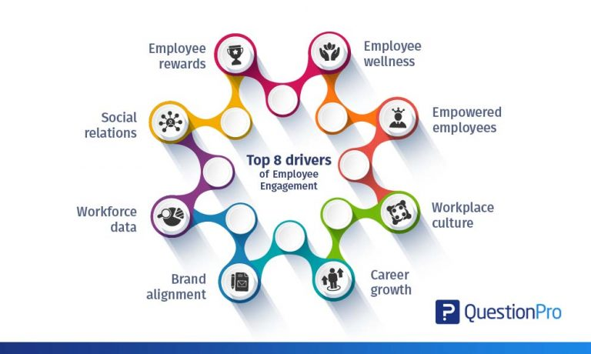

##### Figure 16: Employee performance management

(Source: https://www.questionpro.com)

With the help of this continuous people can progress in their expert advancement by deciding their assets and regions for development. Execution audits may be carried out from time to time to assess an individual's progress, identify areas in which improvement is required and recognize exceptional accomplishments (Meyers *et al.* 2020). The HRM team fosters a culture of continuous learning and improvement within the organization by placing a high priority on employee development and putting powerful performance management practices into place. Representatives are encouraged to take responsibility for the development and given the resources and support they need to succeed. This commitment to representative events benefits individual advancement, job satisfaction, and authoritative execution as a whole. A culture of continuous learning and improvement also helps the business adapt to changes and remain competitive in a rapidly changing business environment. To stay aware of the affiliation's deftness and strength, agents are outfitted with the data and capacities vital to answer new entryways and hardships.

### 4.2.4 Employee Satisfaction and Engagement

HRM practices that are effective assist the relationship with developing more elevated levels of agent satisfaction and responsibility. The HRM team looks for proactive ways to set up a positive workplace that encourages open communication, representative prosperity, and a sense of community to increase representative satisfaction (Whysall *et al.* 2019). The HRM group focuses on implementing strategies and drives that emphasize striking a balance between serious and fun activities. To meet the various necessities of agents. They advocate for versatile work plans like remote work and versatile booking. Employees are more satisfied with their jobs when they have more freedom to meet their personal and professional obligations.

Therefore, the HRM group focuses on the significance of clear communication channels they make the way for productive conversation, novel thoughts, and analysis among delegates and leaders through customary correspondence. Delegates experience a sense of trust, support, and responsibility as a result of this comprehensive procedure, as they believe their voices are valued and heard within the organization (Claus 2019). The HRM team also puts a lot of emphasis on initiatives that help employees feel good about themselves. They do ventures and exercises that work on physical and profound well-being, for example, well-being programs, stress the executive's studios, and admission to specialist help programs. The HRM team demonstrates its dedication to assisting employees in achieving a healthy work-life balance and creating a positive work environment by placing a high value on employee well-being.

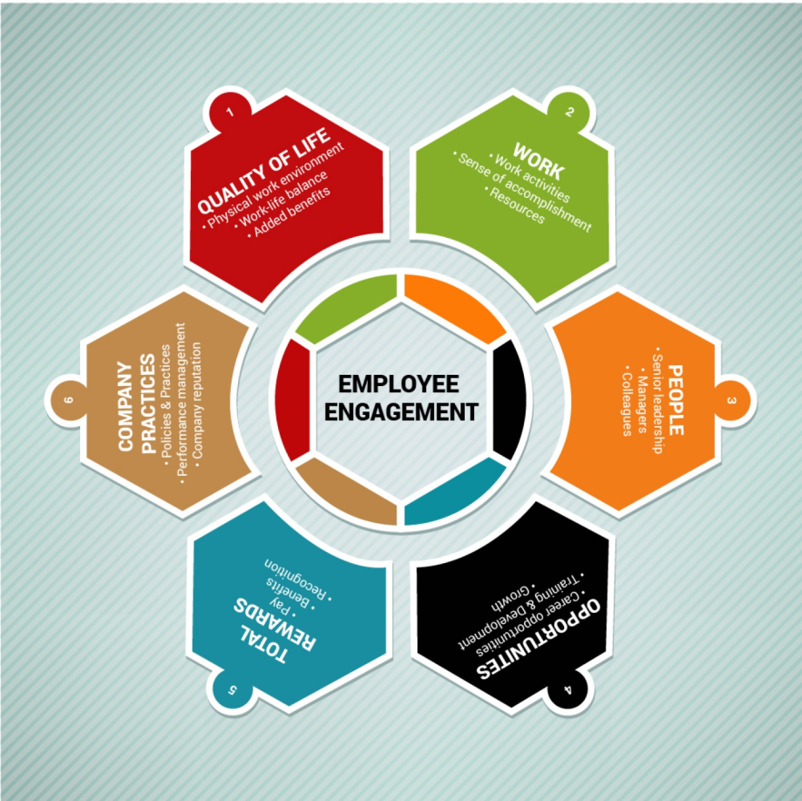

##### Figure 17: Employee Satisfaction

(Source: https://3.bp.blogspot.com)

Also, the HRM group effectively empowers worker improvement and development through career development initiatives, mentoring opportunities, and training programs, they provide opportunities for skill development. By investing in the professional development of their representatives. The HRM group helps them develop a sense of direction and career fulfillment, which in turn encourages them to take on more responsibility and commitment. Agents will certainly finance in their positions when they are content and connected, resulting in improved individual and final execution. Connected with laborers are more imaginative, useful, and receptive to clients, which adds to the organization all general achievement.

### 4.2.5 Employee Productivity and Performance

The HRM group assumes an urgent part in expanding representative efficiency and execution through its preparation and improvement endeavors. By giving workers the information, capacities, and assets, they require, the HRM group gives them the apparatuses they need to go about their responsibilities competently and rapidly (Silic *et al.* 2020). Perceiving a representative's readiness needs is one of the HRM gathering's most significant obligations. They direct broad studies, assessments, and appraisals to figure out which regions require extra information or abilities. Based on these discoveries the HRM group designs and implements preparation programs that address these particular prerequisites.

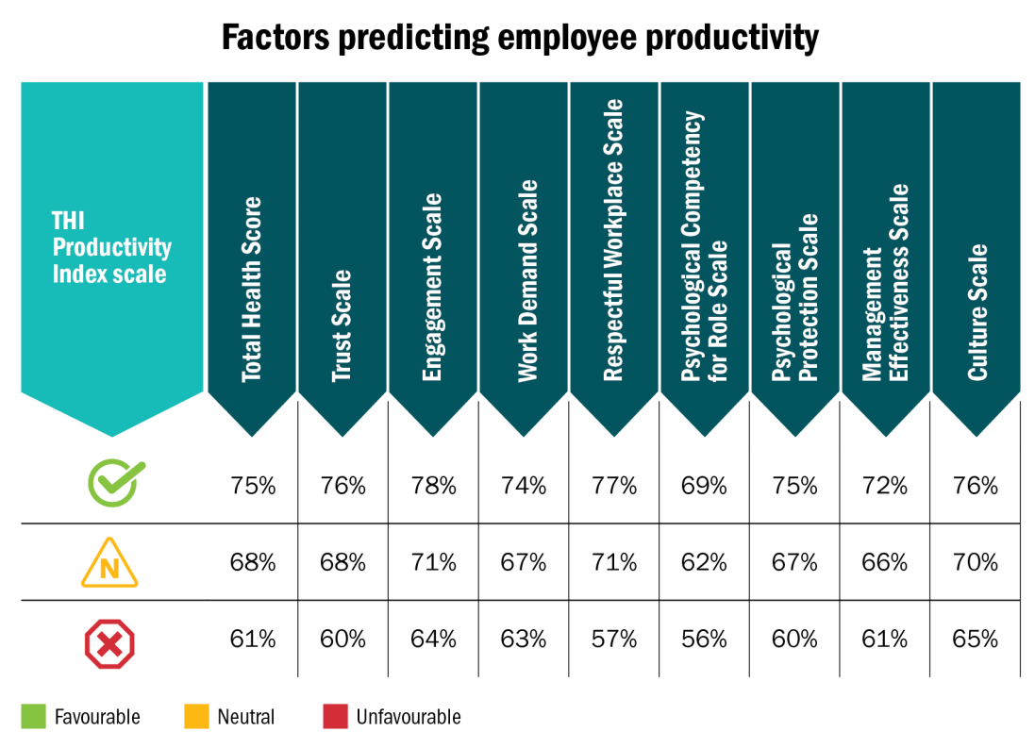

##### Figure 18: Employee Productivity

(Source: https://www.hrreporter.com)

The HRM team provides ongoing support and resources to employees in addition to training programs. They guarantee that laborers approach the devices, data, and innovation they need to take care of their responsibilities competently. In a similar vein, the HRM group develops frameworks and techniques for evaluating and observing employee performance across the board. Clear execution suppositions, goals, and targets are spread out through close joint exertion with directors and supervisors. Employees receive regular coaching and feedback to improve their performance (Stirpe  *et al.* 2022). By adapting execution assumptions to hierarchical goals, the HRM group encourages employees to perform at their best and contribute to the organization's overall success. By taking an interest in representative preparation, advancement, and execution of the board, the HRM group lays out a culture of continuous improvement and responsibility within the organization. Agents feel connected to chip away at their capacities, put new information to use, and show up at their most extreme limit.

### 4.2.8 Perception as a Strategic Partner

A high affirmation rate indicates that the HRM group is regarded as an essential supporter within the organization. This derives that they are really associated with dynamic cycles and add to the progress of business draws near. The HRM group teams up intimately with senior administration and different divisions to guarantee that HR methodology is predictable with the association's general objectives. The HRM team participates in strategic discussions and planning sessions as a strategic partner (Elrehail *et al.* 2019). They offer significant experiences and mastery in labor force organization, the ability of the board, and hierarchical turn of events.

They add to forming the association's central course by finding a spot at the table, guaranteeing that HR contemplations are integrated into the power cycle because it is regarded as an essential partner the HRM group participates in crucial drives like mergers and acquisitions, reconstruction, and expansion plans. They are crucial for evaluating the impact on the workforce, developing progress plans, and effectively managing progress. Their mastery of HR issues lessens dangers and improves the probability of effective results. The HRM team also actively monitors external factors that may influence the organization's strategies for talent acquisition and retention as a strategic partner (Budrienė, and Diskienė 2020). They stay up to date on industry trends, workplace economic conditions, and new developments that could have an impact on the workforce. By anticipating opportunities and challenges, they are able to make significant recommendations to senior management and also modify HR practices ***[Referred to Appendix 5]***.

### 4.2.9 Support from Employees

The HRM group helps workers in deciding their professional objectives by giving data on accessible assets and investigating vocational choices inside the association. This help supports worker commitment and fulfillment since it gives the feeling that proficient improvement is esteemed and upheld. As a result, employees may turn to the HRM team for assistance in resolving issues or conflicts at work (Manuti, *et al.* 2020). The HRM group goes about as an unbiased outsider by working with conversations, giving intercession, and guaranteeing that questions are settled reasonably and reliably. The HRM team boosts employee morale and well-being by fostering a positive work environment and responding to concerns raised by employees.

Employees also turn to the HRM team for advice on employee benefits, policies, and procedures. They might inquire about the procedures for performance evaluations, leave policies, and compensation policies. With regards to guaranteeing that workers approach current and exact data, answer their requests, and comply with the material standards and strategies, the HRM group assumes an urgent part (Navío-Marco *et al.* 2019). It is fundamental to have associations with representatives that are steady to develop a positive workplace. When representatives have the impression that the HRM group is friendly, dependable, and genuinely interested in their success, they develop a sense of belonging and commitment. This prompts higher work fulfillment, broadened capability, and further made degrees of consistency.

### 4.2.10 Resource Constraints

The HRM team's ability to perform their duties effectively may be hindered by a tight budget or insufficient staffing. It may be difficult to invest in necessary HR initiatives, technologies, and programs with limited financial resources. The group's ability to attract and keep top talent, offer competitive compensation and benefits, and implement representative development programs may be hindered as a result of this.

The HRM group may be required to advocate for additional resources from senior management or other partners, regardless of resource objectives. They can present a business case that includes the possible benefit of the hypothesis and the advantages of placing more money in HR drives throughout a drawn-out time (Puvada 2019). The HRM team must emphasize the need for sufficient resources to support HR functions and effectively communicate the impact of resource limitations on the organization's overall performance.

### 4.2.11 Resistance to Change

Delegates or different assistants could conflict with changes because of dread of the worries about capable strength, or delay to leave their standard extents of the shared trait. It is key for the productive execution of HRM drives to overcome this obstacle. The HRM group necessities to plainly and reliably make sense of the explanations behind the change, zeroing in on the advantages and settling any inquiries or questions. Correspondence channels that are clear and open, like metropolitan occasions, notices, and educational gatherings, can help with information sharing and perception.

The improvement and preparation may also be useful in supervising protection against change. The HRM team can help employees feel less anxious and more confident by giving them the knowledge and skills they need to adjust to new procedures. Through pilot projects, center gatherings, or criticism systems, employee involvement in the change cycle can also increase their sense of responsibility and reduce block.

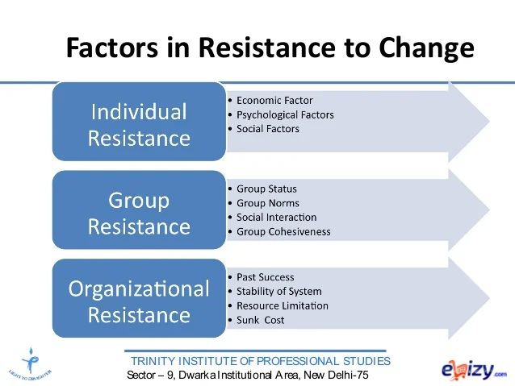

##### Figure 19: Resistance to Change

(Source: https://image.slidesharecdn.com)

### 4.2.12 Employee Well-being and Support

It is essential to emphasize worker well-being and provide adequate assistance for authoritative recovery. During trying times, the HRM group can implement drives like agent support programs, prosperity workouts, and flexible work plans to promote a balance between serious and fun activities and sponsorship workers.

### 4.2.13 Change Management and Communication

During an organization's recovery, effective communication and change management is essential to ensure a smooth transition and lessen resistance (Irawan *et al.* 2021). The HRM team can develop clear communication plans, involve employees in the change process, and provide training and resources.

## 4.3 Discussion

### 4.3.1 Fostering a Motivated and Committed Workforce

Through a variety of strategies and initiatives, the HRM team is crucial in fostering employee commitment and motivation.

***Reward and Appreciation***

Perceiving and Valuing Worker Responsibilities One powerful methodology for affecting and associating with representatives are to perceive and compensate agent achievements and execution (Maheshwari *et al.* 2020). The HRM social affair can design and finish assertion programs that approve individual and get-together achievements. This could come as rewards, motivations, or public affirmation through occasions or grants to show appreciation. By awarding significant prizes and recognition, the HRM department boosts employee contentment, resolve, and responsibility, ultimately enhancing worked-on hierarchical execution.

***Significant Entryways for Laborer Headway and Improvement***

Investing in Representative Events and Learning Opportunities to Encourage a Motivated and Serious Workforce It is urgent to invest in representative events and learning opportunities. The HRM department is able to determine employees' career goals, skill gaps, and preparation needs by means of execution assessments, evaluations, and individual advancement plans (Roundy *et al.* 2022). Then, they can design and finish livelihood improvement ways, instructing projects, and planning undertakings to help laborers with advancing skillfully. Employees are given a sense of direction and responsibility by the HRM group, which offers opportunities for professional advancement and expertise advancement.

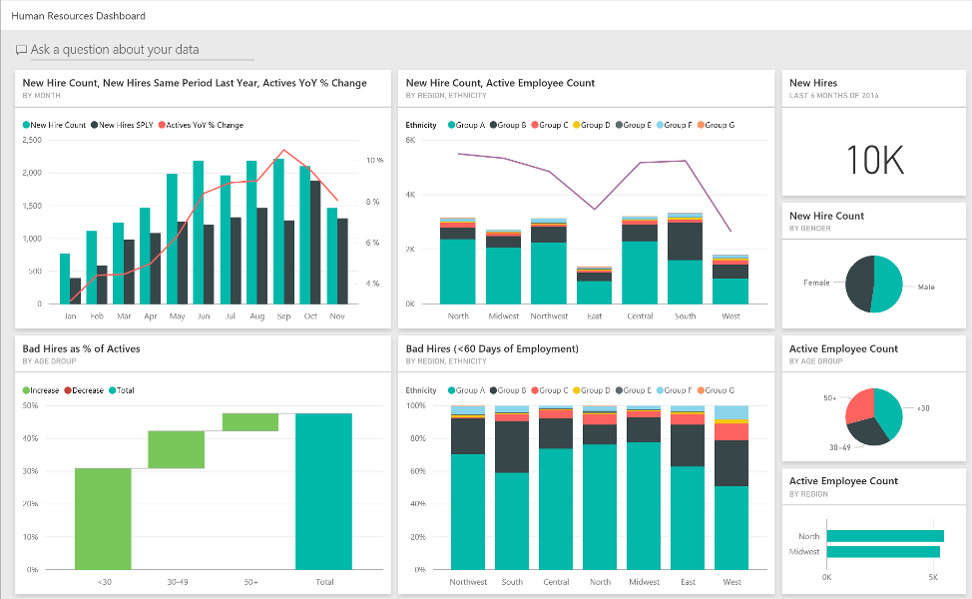

##### Figure 20: Motivated and Committed Workforce

(Source: https://static.wixstatic.com)

***Strength and Freedom***

Connecting with agents and giving them independence in their work can altogether impact their inspiration and awareness of certain expectations. In a steady workplace that the HRM group can make, representatives are urged to get a sense of ownership with their work, decide, and contribute novel ideas (Battour *et al.* 2021). Furnishing representatives with potential chances to take part in dynamic cycles, cultivating an environment of trust and open correspondence, and designating liability are ways of achieving this. The HRM group works on agents' inspiration, work fulfillment, and feeling of obligation by enabling them, which eventually brings away progressive ***[Referred to Appendix 6].***

***Representative well-being and Balance between serious and fun activities***

Inspiration and responsibility are affected by significant variables like the balance between serious and fun activities and work environment prosperity. Adaptable work procedures, wellness initiatives, and drives that strike a balance between serious and fun activities are examples of strategies and practices that the HRM team is able to put into action. By providing resources for the stretch organization, promoting sound work-life coordination, and offering delegate help programs, they can also propel major areas of strength (Hauff, *et al.*2022). By focusing on representative prosperity, the HRM group creates a positive work environment that inspires representatives to be inspired, committed, and responsible.

### 4.3.2. Workforce Diversity and Inclusion of Leveraging Differences for Success

An organization's performance and success depend on its workforce's diversity and inclusion. There are numerous advantages to employing HRM strategies to encourage diversity and inclusion in the workplace.

***Enrolling and Employing Methodologies***

The HRM division is in a situation to carry out thorough enrollment and selecting rehearses that draw in a different pool of rising stars. This could entail successfully locating rising stars from underrepresented groups, employing a blind resume screening method, and establishing connections with various associations and skill organizations. The HRM group works on the affiliation's headway, creative mind, and decisive reasoning abilities by embracing variety in the labor force.

***Various Workplaces***

It is making a Steady and Deferential Work Environment An enticing work environment is important to boost the advantages of variety. Policies, procedures, and training programs that promote diversity awareness, cultural sensitivity, and respectful communication are developed by the HRM team (Zhang *et al.* 2020). It is likewise conceivable to lay out representative asset gatherings or proclivity organizations, which deal with support and a feeling of having a place with workers from different foundations. By creating a strong and conscious environment, the HRM team improves teamwork, commitment, and overall hierarchical execution.

***Different Points of View and a Free Headin***

Variety contribute a large number of points of view and encounters to the table, which can help the association in development and critical thinking. These points of view can be used by the HRM team to encourage diverse teams and inclusive decision-making. The HRM team makes it possible to conduct a more in-depth analysis of both opportunities and challenges by creating a setting where different points of view are valued and heard. Plan creativity improves, direction improves, and hierarchical execution improves as a result.

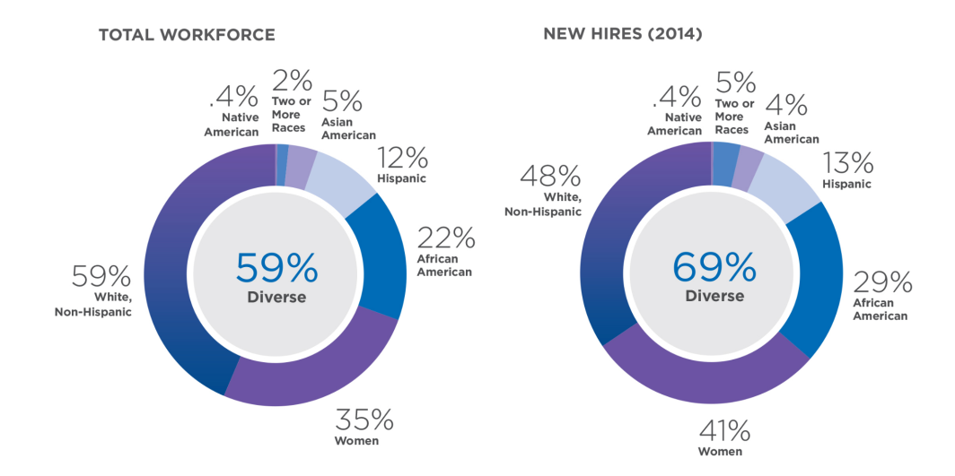

##### Figure 21: Workforce Diversity and Inclusion

(Source: http://corporate.comcast.com)

***Training for racial mindfulness and social capability***

The HRM team can offer diversity training programs and encourage employees to be culturally competent in order to maximize workforce diversity. Employees benefit from these initiatives in understanding and appreciating other cultures, beliefs, and values (Ho and Kuvaas 2020). Coordinated effort and correspondence between individuals from various groups are simplified by the HRM group. This makes it possible to be more creative, solve problems more effectively, and get better performance results.

***Maintenance and Specialist Responsibility***

Cultivating a Positive and Exhaustive Workplace A thorough workplace is essential for holding different capacities. The HRM group can support strategies that make professionals from all organizations feel valued, appreciated, and included. This might involve doing assortment and consolidation estimations, guiding customary delegate audits to assess thought bits of knowledge, and going to any issues or openings that might exist. By creating a positive and comprehensive work environment, the HRM department improves employee commitment and retention.

### 4.3.3. Harnessing the Power of HR Technology

The HRM group can involve hr innovation in different ways of working on tasks, empower information-driven choices, and further develop representative encounters.

**HR data frameworks (HRIS):** HR operations can be simplified with the use of an HRIS, employee data can be made more accessible and accurate, administrative tasks can be automated, and hr operations can be simplified with the use of an HRIS (Schröder *et al.* 2022). The HRM group can actually oversee worker records, screen time and participation, benefits, and improve finance methods with the use of an HRIS, the hr operations can be simplified using hr innovation, and the hrm team can save time and money and concentrate on crucial hr drives that focus on hierarchical execution ***[Referred to Appendix 7]***.

**Systems for talent management:** It can be enhancing performance, recruitment, and development talent management systems offer all-encompassing solutions for employee development, performance management, and recruiting. These systems can be used by the HRM group to streamline the enrollment process, automate performance reviews, and collaborate with agent development drives (Salas‐Vallina *et al.* 2021). The quality of hires, employee performance, and overall organizational success are all enhanced by these technologies, which make efficient candidate sourcing, objective performance evaluations, and personalized development plans possible.

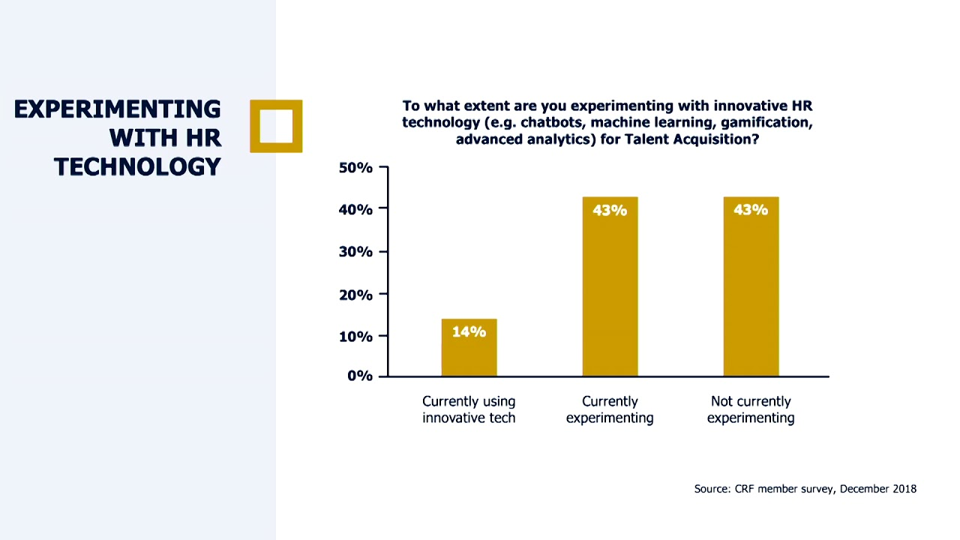

##### Figure 22: Harnessing the Power of HR Technology

(Source: https://i.ytimg.com)

**Individual Investigations:** Driving Information Driven Independent Direction Individuals Examination Refers to The Process of Using Information and Investigation to make well-informed HR decisions. The HRM Group can utilize HR innovation to gather and break down an assortment of HR measurements, for example, representative execution, turnover rates, and preparing viability (Schloemer-Jarvis *et al.* 2022). This information-driven approach enables the HRM group to further develop execution results by proactively resolving issues, advancing hr strategies, and adapting them to hierarchical targets.

### 4.3.4. Navigating Change for Organizational Success

Change is inevitable in today's unique business environment, and the HRM group plays a crucial role in effectively examining and overseeing change by minimizing resistance, maximizing employee engagement and productivity, and ensuring smooth transitions, effective change management contributes to the success of an organization.

***Changing Organization and Writing***

Portraying the objectives, degree, and expected results. The HRM gathering can encourage change in the board methods by clearly describing the drive's objectives, scope, and expected results (Walkowiak 2023). They can also establish communication channels to ensure that specialists are well-informed and connected throughout the change collaboration. The likelihood of the change being implemented successfully increases if all parties involved communicate openly and promptly.

***Worker Obligation and Consolidation***

In order to persuade employees to accept the change and be committed. It is essential to mobilize them and give them more power. Employees must be involved in the change process the HRM group can work with a representative commitment by providing opportunities for information (Lee and Szkudlarek 2021), It can be criticism, and association in navigation. Workers develop a sense of responsibility and are more likely to contribute their thoughts, concerns, and perspectives as a result of training employees to be change specialists. The HRM department fosters a stable and cooperative atmosphere that encourages successful change implementation.

***Education and training***

The HRM team is capable of designing and implementing training and development programs to provide employees with the knowledge and skills they need to successfully navigate the change. These projects might incorporate studios, e-learning modules, or hands-on preparation to guarantee that representatives have what it takes they need to acknowledge the change and add to it by putting resources into delegating game plans and improvement (Harney. and Collings 2021). The HRM pack empowers specialists to change new positions, responsibilities, and ways of managing work.

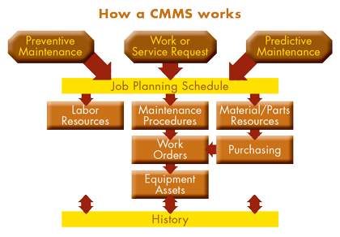

##### Figure 23: Education and training in HRM

(Source: http://www.mcsmag.com)

***Drive and backing for change***

HRM group support for and's strengths. They can provide employees with direction, resources, and support throughout the change interaction. This could be accomplished through one-on-one coaching, group meetings, or support networks to address problems employees are having, give them clarity, and help them out by being accessible and transparent during times of growth (Drosos *et al.* 2021). The HRM group ensures that employees are supported throughout the process.

### 4.3.5. Key Performance Indicators (KPIs) of Metrics for Assessing HRM Effectiveness

To pinpoint locales for improvement and confirmation of advancing accomplishment, HRM practices ought to be assessed. The key execution markers (KPIs) or measurements provide useful insights into the impact and viability of executive-driven human assets. The HRM group can set up and screen these markers with the goal can assess their show and pursuing choices in view of the data they have.

***The Turnover Rate***

The employee turnover rate is a common key performance indicator (KPI) used to evaluate an organization's capacity to retain talent. The HRM team is able to identify any unnoticed issues that have an effect on employee commitment and maintenance by studying and dissecting turnover rates. High turnover rates may be caused by dissatisfaction, a lack of learning opportunities, or inadequate HR support (Fanaei *et al.* 2023). The HRM team is able to increase maintenance and contribute to overall authoritative execution by focusing on the primary drivers, such as the establishment of productive career advancement projects or drives to increase employee commitment.

***Time-to-Fill***

Assessing Enrollment Effectiveness “Time-to-fill” is a metric that actions how it requires to fill open positions. Enrollment flaws with a high chance of being filled may be identified by lengthy endorsement procedures, ineffective obtaining methods, or inadequate up-and-coming candidate screening methods by keeping track of how long it takes to fill a position. The HRM team can identify areas for improvement in the recruitment process and make adjustments to streamline operations. This can result in shorter opening costs, improved competitor quality, and faster use cycles.

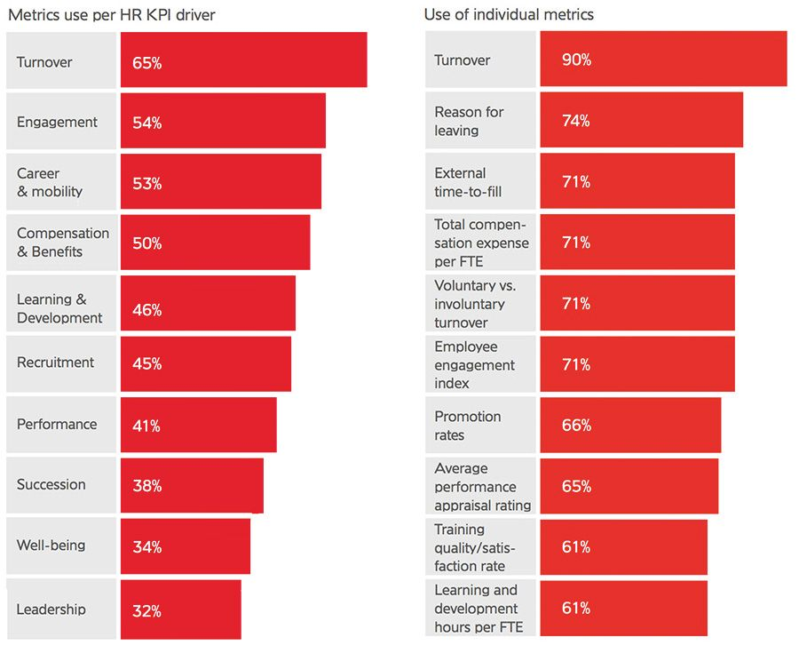

##### Figure 24: KPI performances and matrix

(Source: https://www.consultancy.eu/illustrations/news)

***Investing money in education and preparation***

“Evaluating Employee Development Investing” in representative preparation and advancement is crucial when it comes to expanding one's knowledge and skills. The HRM group can evaluate the effect on the representative turn of events and execution by following the quantity of preparing programs and their viability. The organization's dedication to professional development can be seen in its agent support rates, post-getting-ready evaluations, and planning hours per worker. The HRM gathering can guarantee that representatives gain the fundamental capacities critical to winning in their positions, in this way extending commonly conclusive achievement, by reliably surveying and further creating game plan drives.

***Employee Satisfaction Surveys***

The HRM team can design and administer surveys on topics like job satisfaction, work-life balance, organizational culture, and effective communication. By inspecting outline results, the HRM gathering can recognize locales for advancement, address laborer concerns, and execute systems to help agent satisfaction and thriving. Efficiency, inspiration, and generally speaking hierarchical execution are all advantages of a cheerful workplace and high representative fulfillment.

### 4.3.6. Continuous Improvement of Enhancing HRM Practices for Ongoing Success

Continuous improvement, which guarantees that HR techniques and practices adjust to moving authoritative prerequisites and market patterns, is a fundamental part of HRM. When looking for ways to improve HRM opportunities and practices, the HRM team is very important.

***Evaluation and Criticism***

The HRM group can effectively request input from partners, directors, and representatives to become familiar with how well HRM rehearses work. Common evaluation and criticism methods like execution audits, studies, and center gatherings take into account the identification of growth areas. By gathering and examining input, the HRM group can decide on qualities, shortcomings, and valuable chances to upgrade HRM practices and better adjust them to hierarchical goals.

***Best Practices and Benchmarking***

When looking for ways to improve, HRM practices can be compared to industry standards and best practices (Dvulit *et al.* 2019). The HRM team is able to study and evaluate novel solutions to HRM problems that other successful businesses have used. The HRM gathering can drive consistent improvement and stay before industry designs via completing and changing best deals with, ensuring advancing accomplishment.

***Innovation and adoption of Technology***

Using HR Innovation to Continue to Develop Practices and Drive Constant Improvement The HRM Group can use innovation to Continue to Develop Practices in HR Management and Drive Constant Improvement. They can streamline techniques; motorize administrative endeavors, and gain pieces of information from data-driven examination by utilizing cutting-edge HR propels like HRIS capacity the board programming, and assessment gadgets. The HRM group can utilize this data to pursue better choices, distinguish regions for development, and further develop HRM practices to guarantee to progress achievement. Virtual onboarding platforms, online training modules, and mobile applications for employee self-service are innovative solutions that increase engagement and efficiency by embracing technological advancements.

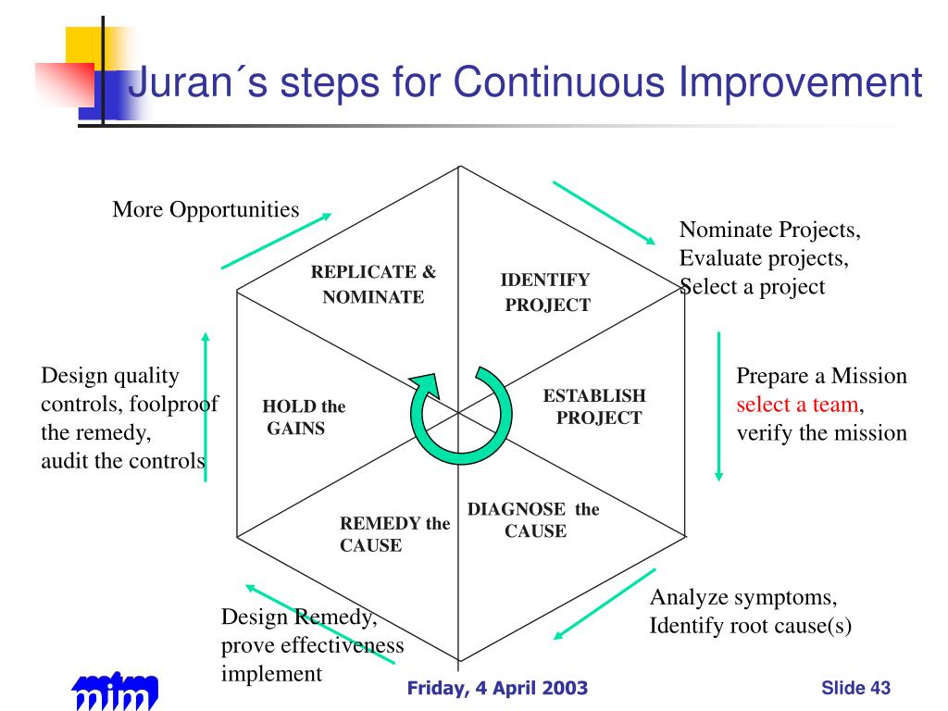

##### Figure 25: Continuous improvement in HRM

(Source: https://image1.slideserve.com)

***Worked with Effort and Learning Society***

The HRM team can create an atmosphere where employees are encouraged to share their thoughts, experiences, and knowledge. This can be achieved in various ways, including networks of training, stages for information sharing, and cross-utilitarian coordinated effort. The HRM group makes sure that representatives are always improving their skills, staying up to date on changes in the industry, and contributing to the improvement of HRM training by encouraging a learning society.

## 4.4 Conclusion

This report took at how HRM associations were bridling the force of HR development and observed that change is fundamental for legitimate achievement. Utilizing HR technology like HRIS, the ability of the executives’ frameworks, self-administration entrances, and individuals’ investigation, the HRM group can smooth out procedures, further develop independent direction, enable representatives, and further develop HR practices. Also, the HRM group guarantees smooth progressions, diminishes impediments, and increments agent responsibility and effectiveness during development seasons by carrying out fruitful changes to the board methods, like clear planning and correspondence, specialist responsibility and commitment, readiness and headway, authority and support, and evaluation and steady improvement. These endeavors aid in working on general execution, hierarchical flexibility, and dexterity in a constantly shifting business environment. HRM altogether affects an association's picture.

By cultivating a motivated and serious workforce, employing variety, equipping the HR innovation force, really exploring change, laying out key execution pointers for evaluating HRM viity, and consistently developing HRM exercises, the HRM group plays a crucial role in driving hierarchical success. Through the essential arrangement, ability to obtain and maintain, representative turn of events and execution of the executives, insight as an essential partner, support from workers, asset limitations, protection from change, representative prosperity and backing, and change the board and correspondence, the HRM team ensures that HR practices adhere to hierarchical objectives, increases worker fulfillment and commitment, and really oversees change. The HRM group contributes to the organization's ongoing success and efficiency by consistently evaluating and developing HRM practices.

# Chapter 5: Conclusion

## 5.1 Introduction

HRM can be considered an essential factor in an organization as it helps in fulfilling the needs of the employees by providing support and guidance to them. Besides the "hiring" and "firing" of employees, HRM plays various significant roles in an organization. It can help in providing training to the employees (Eyupoglu and Tashtoush, 2020). It also helps in giving rewards after assessing the performance of the employees in the provided tasks. In this way, HRM departments continuously work as motivators to the employees in doing their work. It addresses meetings in order to discuss the performance and try to solve any errors that have been identified in the discussion.

## 5.2 Conclusion

Nowadays when businesses are expanding largely to the international height or organizations are trying their best to achieve national recognition, small and medium enterprises are also emerging in a large amount of numbers in recent years. In this scenario, there is a huge importance of human resource management that can be seen in the prosperity of the organization in the long run. There is no gain in saying from the fact that the most valuable assets in the organization and the departments which are associated with handling the people of the organization can be considered the most important factor in this regard. From the business perspective, it can be seen that there is a high competitive rivalry which is going on between the organizations which are internationally famous as well as the organizations which are new in this field. Human Resource Management can be considered an essential aspect for SMEs as it helps in handling the business with limited resources. With the help of this department, the organizations are not only looking into human resources but also looking into the performance of sustainable development and CSR. Therefore it can be said that HRM truly has a high impact on the performance of a business organization

## 5.3 Linking with Objectives

**Understanding the importance of the HRM team in any organization**

Human resources can be considered an important aspect of the organization for multiple reasons. Members related to HR while performing in a small business organization provide several types of services to the employees which could help in enhancing the experience of the employees through strengthening the operation of a business in the workforce (Lockhart *et al*. 2020). Strategic management can be considered the first thing which can be done by the HR members. Improving the bottom line of the company is the way how an organization can be helped by the success of an organization, it helps severely in decision-making that helps in the assessment of the workforce regarding the demand of the business in future.

**Assessing the impact of the HRM team in the organization**

With the help of the compensation structure that has been set by the company in order to construct a realistic formation of the other structure in comparison with the other business organization in the same field. It is necessary to construct a competitive voice structure by following the competitive market regarding the skills of the employees (Dodokh, 2020). It must be looked after so that the employees with the same skill can get the same kind of wages. The HR department has been looked after thoroughly in this process. So, it can be identified that the HRM team in an organization is associated with the task which is considered as the utmost priority for the prospect of the business.

**Investigating the acceptance rate for the HRM team in the organization**

The departments of HRM help in analyzing the benefits of the organization to reduce the cost of companies which are related to the turnover or the replacement of workers. Managing the risks and looking into safety can also be associated with HRM (Iqbal, 2019). It helps in decreasing the issues related to liability by providing proper training and development to the employee it also looks after the workforce so that employees can get job satisfaction after working in the concerned organization.

**Identifying the limitations of HRM in the organization**

It has been identified already that HRM departments in organizations are loaded with advantages and are not free from limitations. The department of HRM must get support from the higher authority as it can help in bringing the best results in the process of the implementation of the HRM. Improper actualization can be considered another limitation of the HRM process (Krithika *et al*. 2019). While generating the policies of human resources the needs of the employees and the aspiration must be looked into as an utmost priority. Many organizations conduct development programs which are not adequate to give proper training to the employees. It has also been noted that the information which has been handed to the team members of the HRM is not sufficient enough to understand the organization.

**Recognizing effective strategies regarding the practices of the HRM for the recovery of the**

**Organization**

Several strategies can be incorporated by an organization for recovering the concerned organization from distress. It can help in constructing a detailed understanding of the objectives of the constant company. It can also assess the capacity of the HR department in the aspect of the company goals (Mousa and Othman, 2020). It also looks into the estimation of the HR recruitments of the company in the future. It helps in determining the necessary tools for the completion of the job strategy that must be implemented by the HRM department for evaluating the action of the organization.

## 5.4 Recommendation

An effective HR team can be highly beneficial for the organization in several ways. In order to become a successful manager, it is recommended to develop relationships with the employees emotionally as emotional collection can help in building the task between the employer and the employee. It is also suggested to do effective communication as communication can be regarded as an essential aspect of HR management. Having a vision is also necessary to become a successful HR manager. Therefore it is recommended to be visionary while walking as an HR manager in an organization.

# References

Abbas, J. and Kumari, K., 2021. Examining the relationship between total quality management and knowledge management and their impact on organizational performance: a dimensional analysis. *Journal of Economic and Administrative Sciences*, (ahead-of-print).

Al Doghan, M.A., Bhatti, M.A. and Juhari, A.S., 2019. Do psychological diversity climate, HRM practices, and personality traits (big five) influence multicultural workforce job satisfaction and performance? The current scenario, literature gap, and future research directions. *Sage Open*, *9*(2), p.2158244019851578.

Al-Harazneh, Y.M. and Sila, I., 2021. The impact of E-HRM usage on HRM effectiveness: highlighting the roles of top management support, HR professionals, and line managers. *Journal of Global Information Management (JGIM)*, 29(2), pp.118-147.

Al-Qudah, S., Obeidat, A.M. and Shrouf, H., 2020. The impact of strategic human resources planning on the organizational performance of public shareholding companies in Jordan. Problems and Perspectives in Management, 18(1), p.219.

Al-Qudah, S., Obeidat, A.M. and Shrouf, H., 2020. The impact of strategic human resources planning on the organizational performance of public shareholding companies in Jordan. *Problems and Perspectives in Management*, *18*(1), p.219.

Alshammari, A.A., 2020. The impact of human resource management practices, organizational learning, organizational culture and knowledge management capabilities on organizational performance in Saudi organizations: a conceptual framework. *Revista Argentina de Clínica Psicológica*, *29*(4), p.714.

Alshammari, A.A., 2020. The impact of human resource management practices, organizational learning, organizational culture and knowledge management capabilities on organizational performance in Saudi organizations: a conceptual framework. Revista Argentina de Clínica Psicológica, 29(4), p.714.

Alshammari, A.A., 2020. The impact of human resource management practices, organizational learning, organizational culture, and knowledge management capabilities on organizational performance in Saudi organizations: a conceptual framework. Revista Argentina de ClínicaPsicológica, 29(4), p.714.

Anwar, G. and Abdullah, N.N., 2021. The impact of Human resource management practice on Organizational performance. *International journal of Engineering, Business and Management (IJEBM)*, *5*.

Anwar, G. and Abdullah, N.N., 2021. The impact of Human resource management practice on Organizational performance. International Journal of Engineering, Business, and Management (IJEBM), 5.

Arifani, A.Z.T. and Susanti, A.Y., 2020. Literature Review Factors Affecting Employee Performance: Competence, Compensation, And Leadership. *Dinasti International Journal of Economics, Finance & Accounting*, *1*(3), pp.538-549.

Arifani, A.Z.T. and Susanti, A.Y., 2020. Literature Review Factors Affecting Employee Performance: Competence, Compensation, And Leadership. *Dinasti International Journal of Economics, Finance & Accounting*, *1*(3), pp.538-549.

Bakator, M., Petrović, N., Borić, S. and Đalić, N., 2019. Impact of human resource management on business performance: A review of literature. *Journal of engineering management and competitiveness (JEMC)*, *9*(1), pp.3-13.

Battour, M., Barahma, M. and Al-Awlaqi, M., 2021. The Relationship between HRM Strategies and Sustainable Competitive Advantage: Testing the Mediating Role of Strategic Agility. Sustainability, 13(9), p.5315.

BRM, 2021. *Deductive approach (deductive reasoning) - research-methodology*, *Research*. Available at: https://research-methodology.net/research-methodology/research-approach/deductive-approach-2/ (Accessed: 13 May 2023).

Budrienė, D. and Diskienė, D., 2020. Employee engagement: types, levels and relationship with practice of HRM. Malaysian e commerce journal, 4(2), pp.42-47.

Cheng, M.M. and Hackett, R.D., 2021. A critical review of algorithms in HRM: Definition, theory, and practice. Human Resource Management Review, 31(1), p.100698.

Claus, L., 2019. HR disruption—Time already to reinvent talent management. BRQ Business Research Quarterly, 22(3), pp.207-215.

Danilwan, Y. and Dirhamsyah, I.P., 2022. The Impact of The Human Resource Practices on The Organizational Performance: Does Ethical Climate Matter? Journal of Positive School Psychology, 6(3), pp.1-16.

Danilwan, Y., Isnaini, D.B.Y., Pratama, I. and Dirhamsyah, D., 2020. Inducing organizational citizenship behavior through green human resource management bundle: drawing implications for environmentally sustainable performance. A case study. *Journal of Security and Sustainability Issues*, *10*(October), pp.39-52.

Darvishmotevali, M. and Altinay, L., 2022. Green HRM, environmental awareness and green behaviors: The moderating role of servant leadership. *Tourism Management*, *88*, p.104401.

Dastmalchian, A., Bacon, N., McNeil, N., Steinke, C., Blyton, P., Satish Kumar, M., Bayraktar, S., Auer-Rizzi, W., Bodla, A.A., Cotton, R. and Craig, T., 2020. High-performance work systems and organizational performance across societal cultures. *Journal of International Business Studies*, *51*, pp.353-388.

Davidescu, A.A., Apostu, S.A., Paul, A. and Casuneanu, I., 2020. Work flexibility, job satisfaction, and job performance among Romanian employees—Implications for sustainable human resource management. *Sustainability*, *12*(15), p.6086.

Dixit, R. and Sinha, V., 2020. Addressing Training and Development Bottlenecks in HRM: Facilitating a Paradigm Shift in Building Human Capital in Global Organizations. In *Contemporary Global Issues in Human Resource Management*. Emerald Publishing Limited.

Dodokh, A., 2020. Impact of human resources management practices on workplace knowledge-hiding behaviour. *International Journal of Knowledge Management Studies*, *11*(3), pp.298-324.

Drosos, D., Kyriakopoulos, G.L., Gkika, E.C., Komisopoulos, F., Skordoulis, M. and Ntanos, S., 2021. Managing change and managerial innovation towards employees satisfaction at workplace. TEM Journal, 10(2), p.597.

Dvulit, Z.P., Zaverbnyy, A.S. and Tylipska, R.B., 2019. Human resources management based on key performance indicators (KPI). Вісник Національного університету “Львівська політехніка”. Серія: Проблеми економіки та управління, (3), pp.90-98.

Elrehail, H., Harazneh, I., Abuhjeeleh, M., Alzghoul, A., Alnajdawi, S. and Ibrahim, H.M.H., 2019. Employee satisfaction, human resource management practices and competitive advantage: The case of Northern Cyprus. European Journal of Management and Business Economics, 29(2), pp.125-149.

Eyupoglu, S.Z. and Tashtoush, L., 2020. The relationship between human resource management practices and organisational citizenship behaviour. *South African Journal of Business Management*, *51*(1), pp.1-11.

Eyupoglu, S.Z. and Tashtoush, L., 2020. The relationship between human resource management practices and organisational citizenship behaviour. *South African Journal of Business Management*, 51(1), pp.1-11.

Fanaei, S., Zareiyan, A., Shahraki, S. and Mirzaei, A., 2023. Determining the key performance indicators of human resource management of military hospital managers; a TOPSIS study. BMC Primary Care, 24(1), p.47.

GyurákBabeľová, Z., Stareček, A., Koltnerová, K. andCagáňová, D., 2020. Perceived organizational performance in recruiting and retaining employees concerning different generational groups of employees and sustainable human resource management. *Sustainability*, *12*(2), p.574.

Halid, H., Yusoff, Y.M. and Somu, H., 2020, May. The relationship between digital human resource management and organizational performance. In First ASEAN Business, Environment, and Technology Symposium (ABEATS 2019) (pp. 96-99). Atlantis Press.

Hamouche, S., 2021. Human resource management and the COVID-19 crisis: Implications, challenges, opportunities, and future organizational directions. *Journal of Management & Organization*, pp.1-16.

Han, Y. and Hong, S., 2019. The impact of accountability on organizational performance in the US federal government: The moderating role of autonomy. *Review of Public Personnel Administration*, *39*(1), pp.3-23.

Harney, B. and Collings, D.G., 2021. Navigating the shifting landscapes of HRM. Human Resource Management Review, 31(4), p.100824.

Hauff, S., Felfe, J. and Klug, K., 2022. High-performance work practices, employee well-being, and supportive leadership: spillover mechanisms and boundary conditions between HRM and leadership behavior. The International Journal of Human Resource Management, 33(10), pp.2109-2137.

Havidz, H.B.H. and Gupron, G., 2019. Determination of employee performance: perceived organizational support, communication, and leadership styles (a human resource management literature study).*Dinasti International Journal of Digital Business Management*, *1*(1), pp.116-131.

Havidz, H.B.H. and Gupron, G., 2019. Determination of employee performance: perceived organizational support, communication, and leadership styles (a human resource management literature study). *Dinasti International Journal of Digital Business Management*, *1*(1), pp.116-131.

He, J., Morrison, A.M. and Zhang, H., 2019. Improving millennial employee well-being and task performance in the hospitality industry: The interactive effects of HRM and responsible leadership. *Sustainability*, *11*(16), p.4410.

Hee, O.C., Halim, M.A., Ping, L.L., Kowang, T.O. and Fei, G.C., 2019. The relationship between human resource management practices and job performance in the courier service industry. *International journal of academic research in business and social sciences*, *9*(3), pp.63-79.

Hee, O.C., Halim, M.A., Ping, L.L., Kowang, T.O. and Fei, G.C., 2019. The relationship between human resource management practices and job performance in the courier service industry. *International journal of academic research in business and social sciences*, *9*(3), pp.63-79.

HHS, 2019. *Data collection*. Available at: https://ori.hhs.gov/education/products/n_illinois_u/datamanagement/dctopic.html#:~:text=Data%20Collection,test%20hypotheses%2C%20and%20evaluate%20outcomes. (Accessed: 12 May 2023).

Ho, H. and Kuvaas, B., 2020. Human resource management systems, employee well‐being, and firm performance from the mutual gains and critical perspectives: The well‐being paradox. Human Resource Management, 59(3), pp.235-253.

Iqbal, A., 2019. The strategic human resource management approaches and organisational performance: The mediating role of creative climate. *Journal of Advances in Management Research*, *16*(2), pp.181-193.

Iqbal, A., 2019. The strategic human resource management approaches and organisational performance: The mediating role of creative climate. Journal of Advances in Management Research, 16(2), pp.181-193.

Irawan, B., Ruhana, F., Nadjib, A. and Sari, A.R., 2021, June. Development of the Public Sector HRM Model in Indonesia’s Public Sector. In 2nd Annual Conference on blended learning, educational technology and Innovation (ACBLETI 2020) (pp. 136-140). Atlantis Press.

Kerdpitak, C. and Jermsittiparsert, K., 2020. The impact of human resource management practices on competitive advantage: Mediating role of employee engagement in Thailand. Systematic Reviews in Pharmacy, 11(1), pp.443-452.

Krithika, J., Divya Priyadharshini, N. and GokulaPriya, J., 2019. Green HRM-Practices In Organisations. *IOSR Journal of Business and Management (IOSR-JBM)*, *21*(3), p.74.

Kuria, M.W. and Mose, T., 2019. Effect of green human resource management practices on organizational effectiveness of universities in Kenya. *Human Resource and Leadership Journal*, *4*(2), pp.1-20.

Lee, E.S. and Szkudlarek, B., 2021. Refugee employment support: The HRM–CSR nexus and stakeholder co‐dependency. Human Resource Management Journal, 31(4), pp.936-955.

Li, R., Du, Y.F., Tang, H.J., Boadu, F. and Xue, M., 2019. MNEs’ subsidiary HRM practices and firm innovative performance: A tacit knowledge approach. *Sustainability*, *11*(5), p.1388.

Lockhart, P., Shahani, N.K. and Bhanugopan, R., 2020. Do organisational culture and national culture mediate the relationship between high-performance human resource management practices and organisational citizenship behaviour?. *International Journal of Manpower*.

Lockhart, P., Shahani, N.K. and Bhanugopan, R., 2020. Do organisational culture and national culture mediate the relationship between high-performance human resource management practices and organisational citizenship behaviour?. International Journal of Manpower.

Maguire, M. and Delahunt, B., 2017. Doing a thematic analysis: A practical, step-by-step guide for learning and teaching scholars. All Ireland Journal of Higher Education, 9(3).

Maheshwari, M., Samal, A. and Bhamoriya, V., 2020. Role of employee relations and HRM in driving commitment to sustainability in MSME firms. International Journal of Productivity and Performance Management, 69(8), pp.1743-1764.

Manuti, A., Giancaspro, M.L., Molino, M., Ingusci, E., Russo, V., Signore, F., Zito, M. and Cortese, C.G., 2020. “Everything will be fine”: A study on the relationship between employees’ perception of sustainable HRM practices and positive organizational behavior during COVID19. Sustainability, 12(23), p.10216.

Meyers, M.C., van Woerkom, M., Paauwe, J. and Dries, N., 2020. HR managers’ talent philosophies: prevalence and relationships with perceived talent management practices. The International Journal of Human Resource Management, 31(4), pp.562-588.

Mira, M., Choong, Y. and Thim, C., 2019. The effect of HRM practices and employees’ job satisfaction on employee performance. Management Science Letters, 9(6), pp.771-786.

Mousa, S.K. and Othman, M., 2020. The impact of green human resource management practices on sustainable performance in healthcare organisations: A conceptual framework. *Journal of Cleaner Production*, *243*, p.118595.

Muisyo, P.K., Qin, S., Ho, T.H. and Julius, M.M., 2022. The effect of green HRM practices on the green competitive advantage of manufacturing firms. *Journal of Manufacturing Technology Management*, *33*(1), pp.22-40.

Navío-Marco, J., Solórzano-García, M. and Palencia-González, F.J., 2019. Human resource management as key pillar of company strategy: Analysis of the line managers’ perception. Journal of Management & Organization, 25(2), pp.175-188.

NGUYEN, D.T., HA, V.D. and DANG, T.T.N., 2020. The impact of human resource management activities on the compatibility and work results. *The Journal of Asian Finance, Economics and Business*, *7*(9), pp.621-629.

Njoku, E., Ruël, H., Rowlands, H., Evans, L. and Murdoch, M., 2019. An analysis of the contribution of e-HRM to sustaining business performance. In *HRM 4.0 For Human-Centered Organizations*. Emerald Publishing Limited.

Opatha, H.H.D.N.P., 2019. Sustainable human resource management. *Sri Lanka: Author*.

Otoo, F.N.K., 2019. Human resource management (HRM) practices and organizational performance: The mediating role of employee competencies. Employee Relations: The International Journal.

Putra, R. and Ali, H., 2022. ORGANIZATIONAL BEHAVIOR DETERMINATION AND DECISION MAKING: ANALYSIS OF SKILLS, MOTIVATION, AND COMMUNICATION (LITERATURE REVIEW OF HUMAN RESOURCE MANAGEMENT). *Dinasti International Journal of Digital Business Management*, *3*(3), pp.420-431.

Puvada, D.D., 2019. Linkages between Hrm Systems, Technology and Management Relations. Acta Universitatis Danubius. Œconomica, 15(5), pp.88-101.

Qablan, N. and Farmanesh, P., 2019. Do organizational commitment and perceived discrimination matter? Effect of SR-HRM characteristics on employee turnover intentions. *Management Science Letters*, *9*(7), pp.1105-1118.

Ramadistaa, R.M.P. and Kismono, G., 2020. The effect of the degree of misfit between human resources management practices and the types of organizational culture on organizational performance. *Gadjah Mada International Journal of Business*, 22(3), pp.301-322.

Roundy, P.T. and Burke-Smalley, L., 2022. Leveraging entrepreneurial ecosystems as human resource systems: A theory of meta-organizational human resource management. Human Resource Management Review, 32(4), p.100863.

Rubel, M.R.B., Kee, D.M.H. and Rimi, N.N., 2021. The influence of green HRM practices on green service behaviors: the mediating effect of green knowledge sharing. *Employee Relations: The International Journal*, *43*(5), pp.996-1015.

Sabiu, M.S., Ringim, K.J., Mei, T.S. and Joarder, M.H.R., 2019. Relationship between human resource management practices, ethical climates, and organizational performance, the missing link: An empirical analysis. *PSU Research Review*.

Salas‐Vallina, A., Alegre, J. and López‐Cabrales, Á., 2021. The challenge of increasing employees' well‐being and performance: How human resource management practices and engaging leadership work together toward reaching this goal. Human Resource Management, 60(3), pp.333-347.

Salas‐Vallina, A., Alegre, J. and López‐Cabrales, Á., 2021. The challenge of increasing employees' well‐being and performance: How human resource management practices and engaging leadership work together toward reaching this goal. *Human Resource Management*, *60*(3), pp.333-347.

Saunders, 2020. *Research Onion by Saunders*, *Google image result for https://i.ytimg.com/vi/h89hk3zfsvg/maxresdefault.jpg*. Available at: https://www.google.com/imgres?imgurl=https%3A%2F%2Fi.ytimg.com%2Fvi%2FH89hK3zFSvg%2Fmaxresdefault.jpg&tbnid=Lb6s2LOPEUIiqM&vet=12ahUKEwi92NnD7oj_AhXFkGMGHczxBcwQMygFegUIARDoAQ..i&imgrefurl=https%3A%2F%2Fwww.youtube.com%2Fwatch%3Fv%3DH89hK3zFSvg&docid=wQb5tvcmI4XtEM&w=1280&h=720&q=research+onion&ved=2ahUKEwi92NnD7oj_AhXFkGMGHczxBcwQMygFegUIARDoAQ (Accessed: 14 May 2023).

Schloemer-Jarvis, A., Bader, B. and Böhm, S.A., 2022. The role of human resource practices for including persons with disabilities in the workforce: A systematic literature review. The InTernaTIonal Journal of human resource managemenT, 33(1), pp.45-98.

Schröder, S., Wiek, A., Farny, S. and Luthardt, P., 2022. Toward holistic corporate sustainability—Developing employees' action competence for sustainability in small and medium‐sized enterprises through training. Business Strategy and the Environment.

Silic, M., Marzi, G., Caputo, A. and Bal, P.M., 2020. The effects of a gamified human resource management system on job satisfaction and engagement. Human Resource Management Journal, 30(2), pp.260-277.

Stankevičiūtė, Ž. and Savanevičienė, A., 2019. Can sustainable HRM reduce work-related stress, work-family conflict, and burnout?. *International Studies of Management & Organization*, *49*(1), pp.79-98.

Stankevičiūtė, Ž. and Savanevičienė, A., 2019. Can sustainable HRM reduce work-related stress, work-family conflict, and burnout? *International Studies of Management & Organization*, *49*(1), pp.79-98.

Stirpe, L., Profili, S. and Sammarra, A., 2022. Satisfaction with HR practices and employee performance: A moderated mediation model of engagement and health. European Management Journal, 40(2), pp.295-305.

Suharti, L. and Sugiarto, A., 2020. A qualitative study OF Green HRM practices and their benefits in the organization: An Indonesian company experience. *Business: Theory and Practice*, *21*(1), pp.200-211.

Walkowiak, E., 2023. Digitalization and inclusiveness of HRM practices: The example of neurodiversity initiatives. Human Resource Management Journal.

Whysall, Z., Owtram, M. and Brittain, S., 2019. The new talent management challenges of Industry 4.0. Journal of management development.

Yong, J.Y., Yusliza, M.Y., Ramayah, T., ChiappettaJabbour, C.J., Sehnem, S. and Mani, V., 2020. Pathways towards sustainability in manufacturing organizations: Empirical evidence on the role of green human resource management. *Business Strategy and the Environment*, *29*(1), pp.212-228.

Zaki, N.A.B.M. and Norazman, I., 2019. The relationship between employee motivation towards green HRM mediates by green employee empowerment: a systematic review and conceptual analysis. *Journal of Research in Psychology*, *1*(2), pp.6-9.

Zhang, X., Lin, Z., Liu, Y., Chen, X. and Liu, D.M., 2020. How do human resource management practices affect employee well-being? A mediated moderation model. Employee Relations: The International Journal, 42(4), pp.903-919.

Zhou, Y., Liu, G., Chang, X. and Wang, L., 2021. The impact of HRM digitalization on firm performance: investigating three‐way interactions. *Asia Pacific Journal of Human Resources*, *59*(1), pp.20-43.

# Appendices

**Appendix 1: Relation between HRM and Ethical Climate**



(Source: https://www.emerald.com)

**Appendix 2: HRM models**



(Source: https://higherstudy.org)

**Appendix 3: AMOL Model**



(Source: https://www.researchgate.net)

**Appendix 4: Conceptual Framework**



(Source: Self-Created in Draw.io)

**Appendix 5: HR efficiency performances**

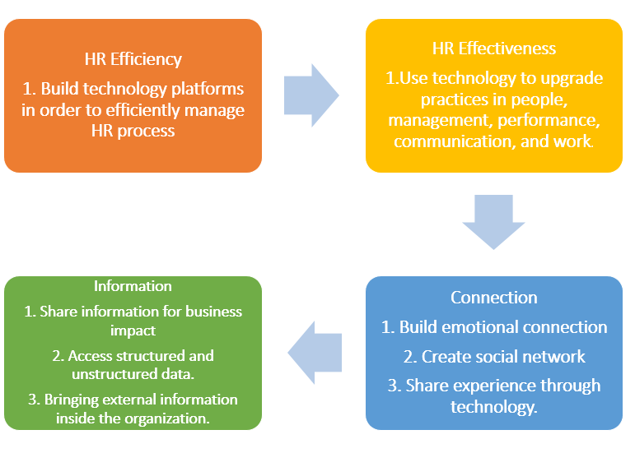

(Source; https://researchleap.com)

**Appendix 6: Strategy of HRM**

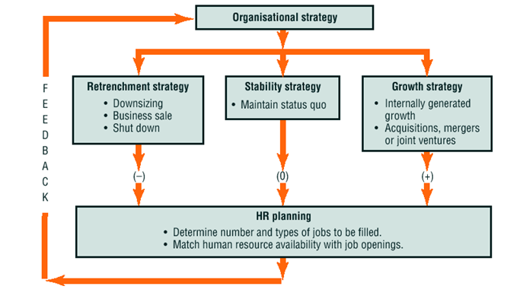

(Source: http://seofiles.s3.amazonaws.com)

**Appendix 7: Impact of HRM**

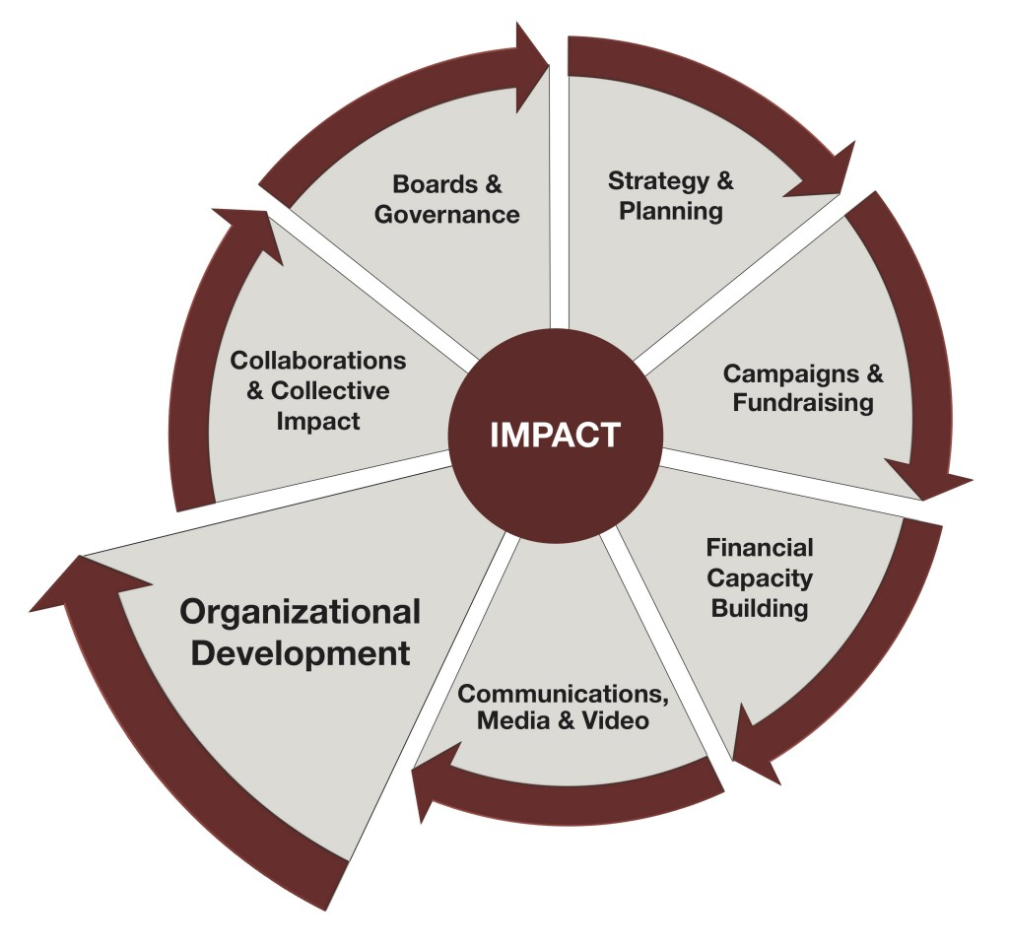

(Source: https://danosky.com)